Lab 1 – AWS – Single FGT Deployment

**Goal** – Deploy a single FortiGate into a single AZ and establish connectivity.

**Task** – Build every component including VPC, subnets, route tables, ENIs, IGW, and FGT EC2.

**Validation** – FortiGate GUI will be accessed remotely.

**Introduction**

In this task, you will learn the foundation of deploying networks in the cloud. While it is easier to deploy an IaC template (such as CloudFormation in later labs), this lab will have you configuring every component to get a basic network in the cloud secured by a single FortiGate.

**Lab**

1 – Navigate to the VPC console and create a new VPC. You can use the search bar at the top or click on the cluster of six squares. The VPC is the term that AWS uses for the virtual network space where you can build your cloud resources.

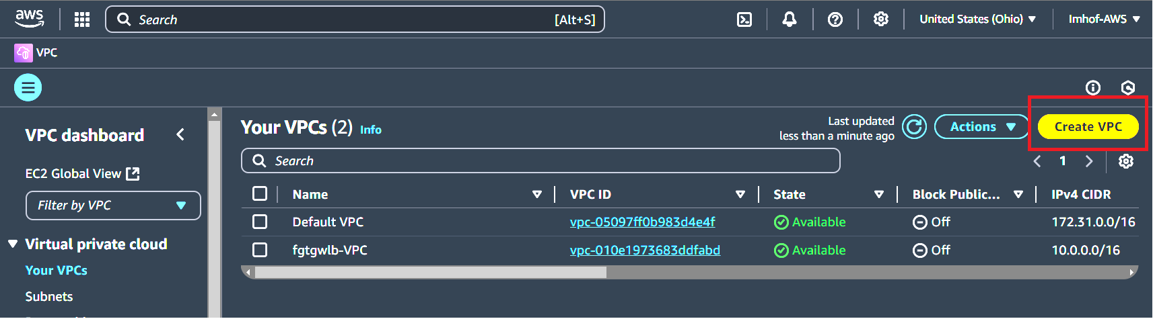

2 – Create VPC with the following parameters:

* Name tag: **SingleVMvpc**
* IPv4 CIDR: **10.255.0.0/16**

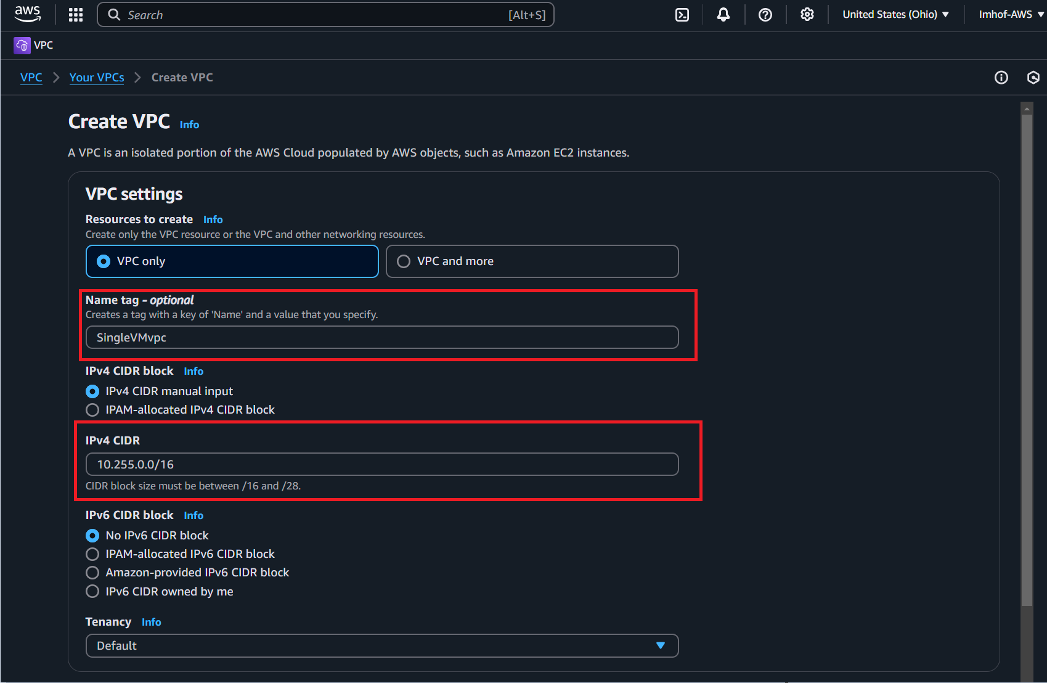

3 – Create VPC by clicking on the **Create VPC** button

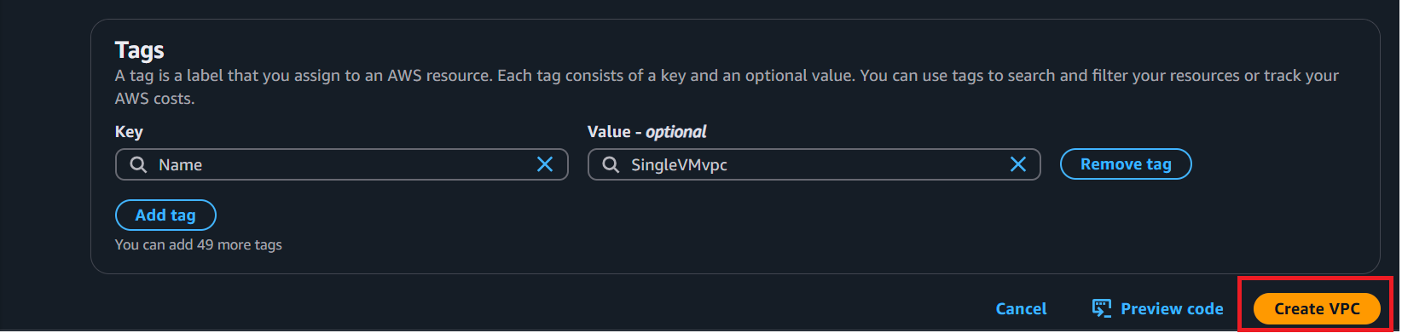

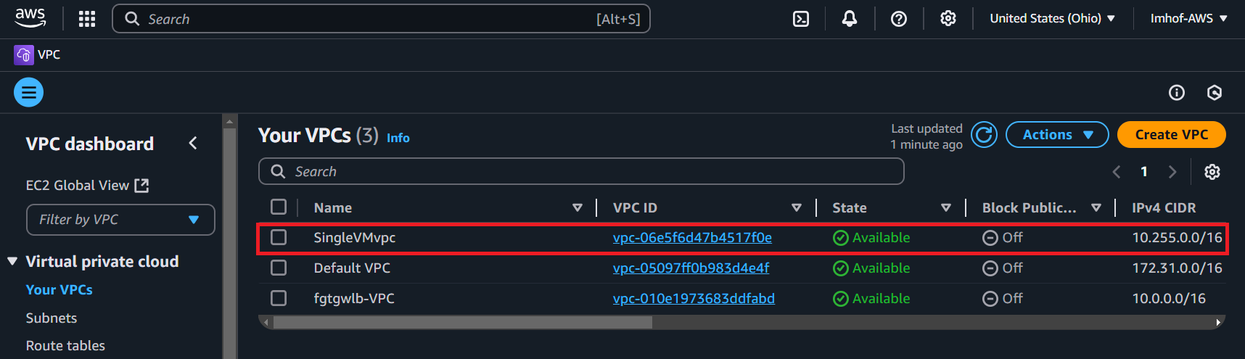

**\*\*\* Document this VPC ID (as well as all resource ID numbers) for future use, AWS doesn’t always include the name field when deploying resources \*\*\***

4 – Navigate to subnets page

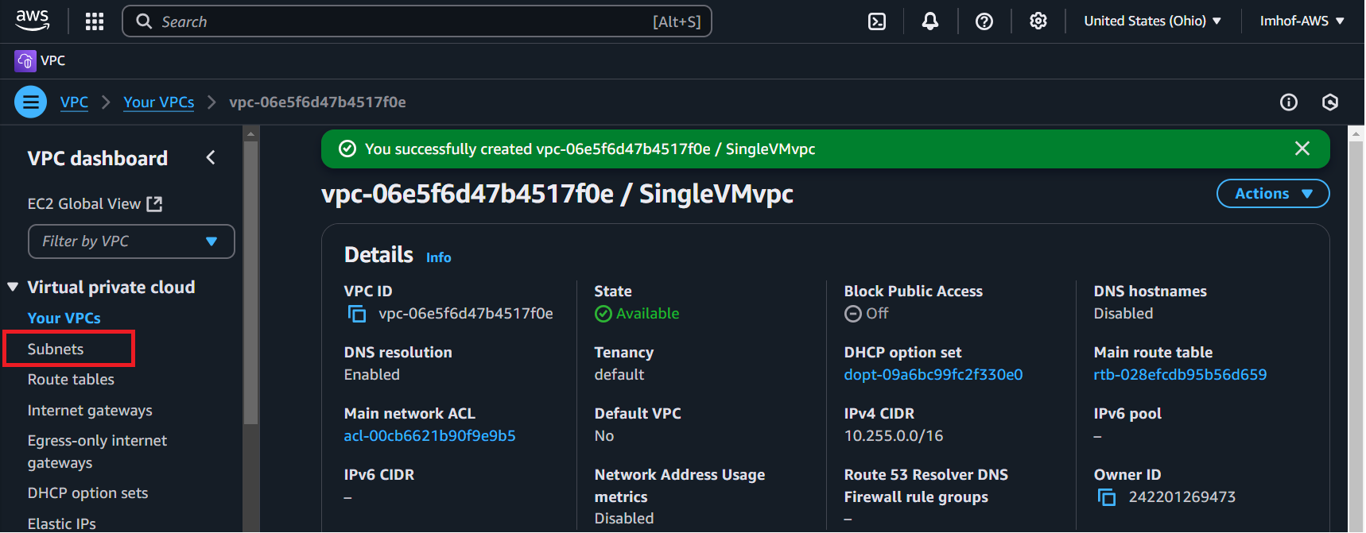

5- Create public subnet using the following parameters:

* VPC ID: **SingleVMvpc**
* Subnet name: **singleVMpublic**
* Availability Zone: **US East (Ohio) / us-east-2a**
* IPv4 VPC CIDR block: **10.255.0.0/16**
* IPv4 subnet CIDR block: **10.255.1.0/24**

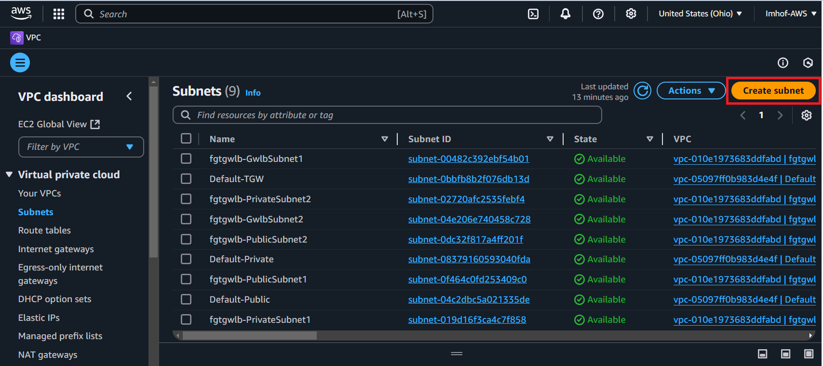

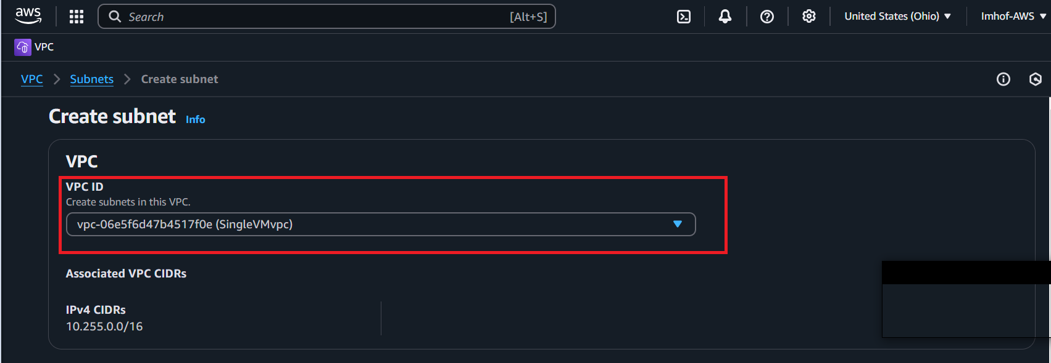

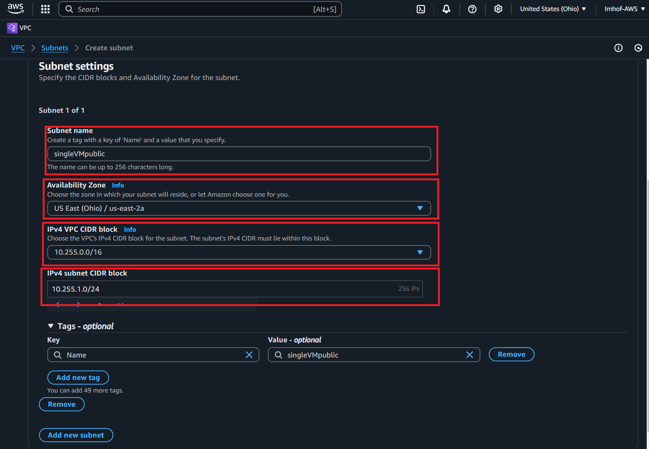



6 – Create private subnet using the following parameters:

* VPC ID: **SingleVMvpc**
* Subnet name: **singleVMprivate**
* Availability Zone: **US East (Ohio) / us-east-2a**
* IPv4 VPC CIDR block: **10.255.0.0/16**
* IPv4 subnet CIDR block: **10.255.2.0/24**

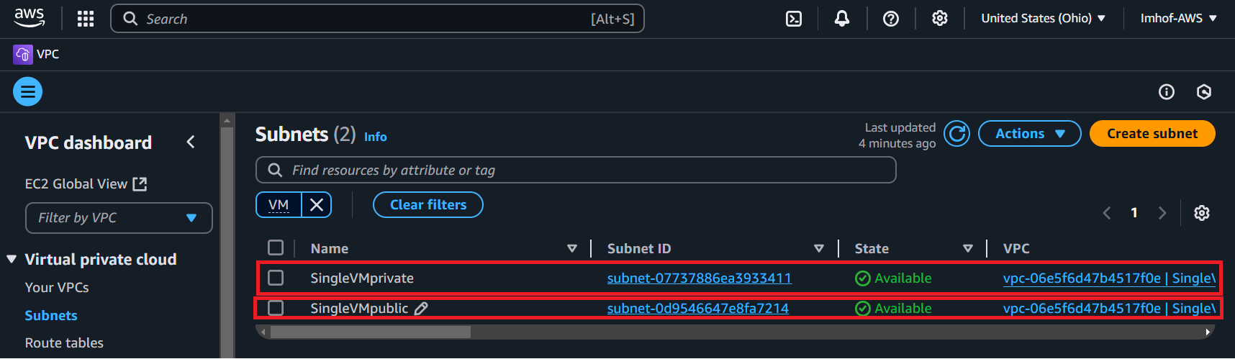

7 – Navigate to “Internet Gateways” and deploy an Internet Gateway to the public subnet for inbound and outbound connectivity to the internet using the following parameters:

* Name tag: **IGW-singleVM**

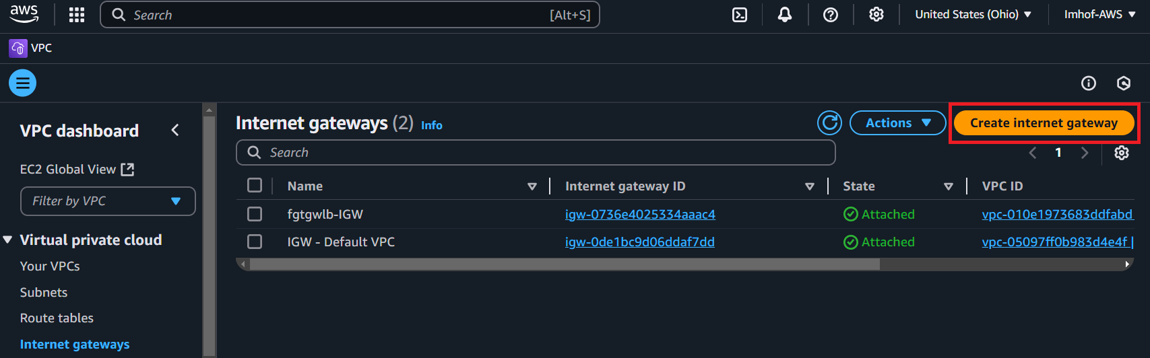

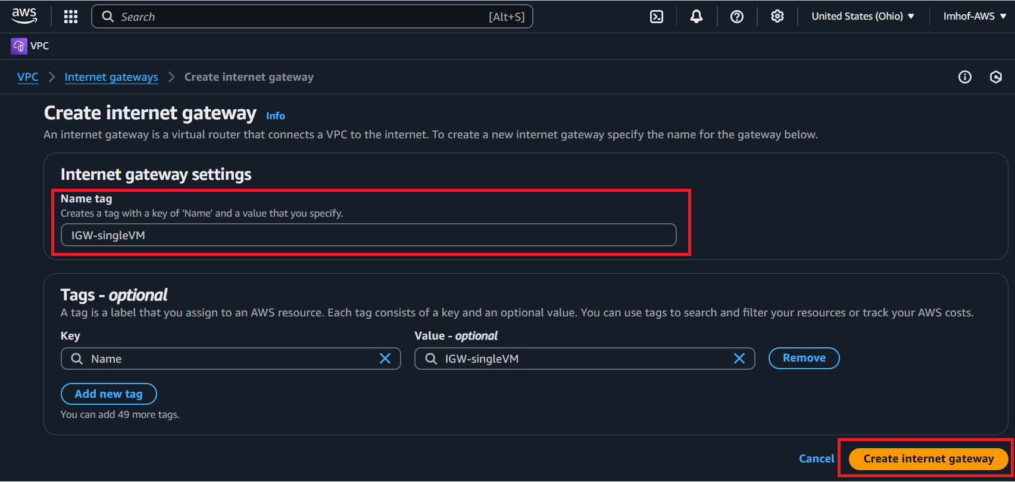

8 - Attach the IGW to your VPC

* Available VPCs: **SingleVMvpc**

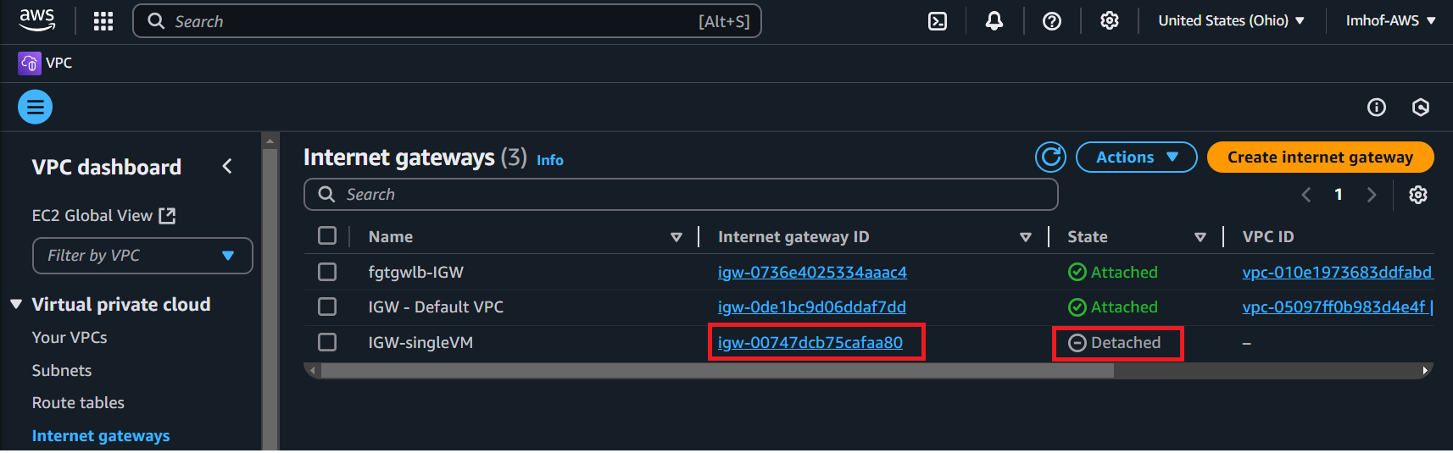

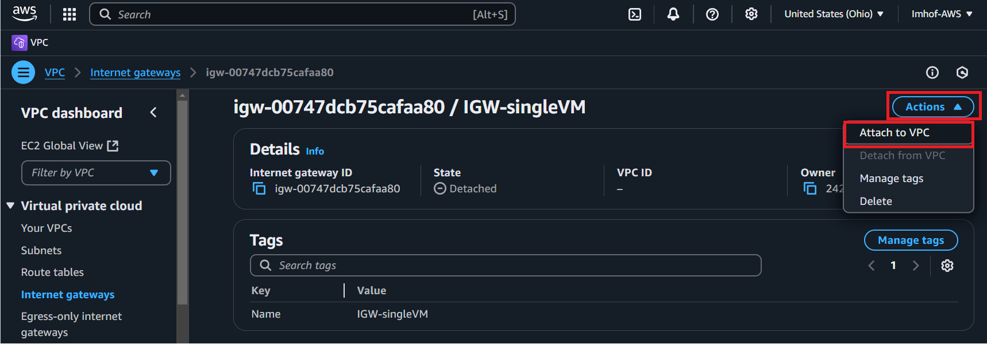

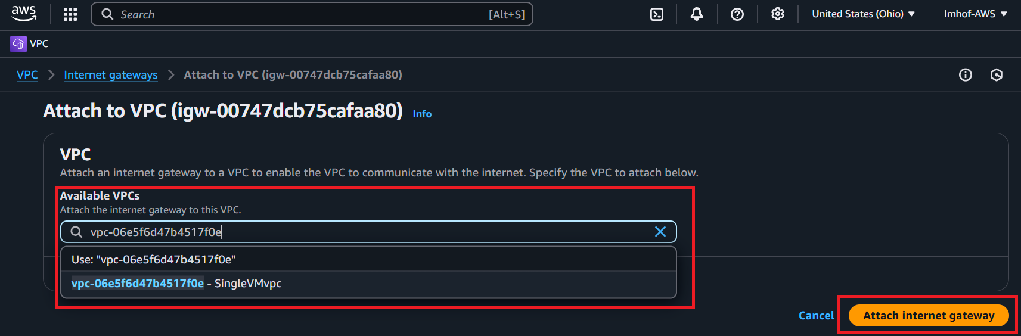

9 – Navigate to Marketplace through the search bar and look for **Fortinet FortiGate Next-Generation Firewall** then deploy the FGT NVA into the public subnet.

* Click on **View purchase options**
* **Subscribe** to the product offering (if not already done)
* Click on **Continue to Configuration**
* **Do not select** an option under Contract options

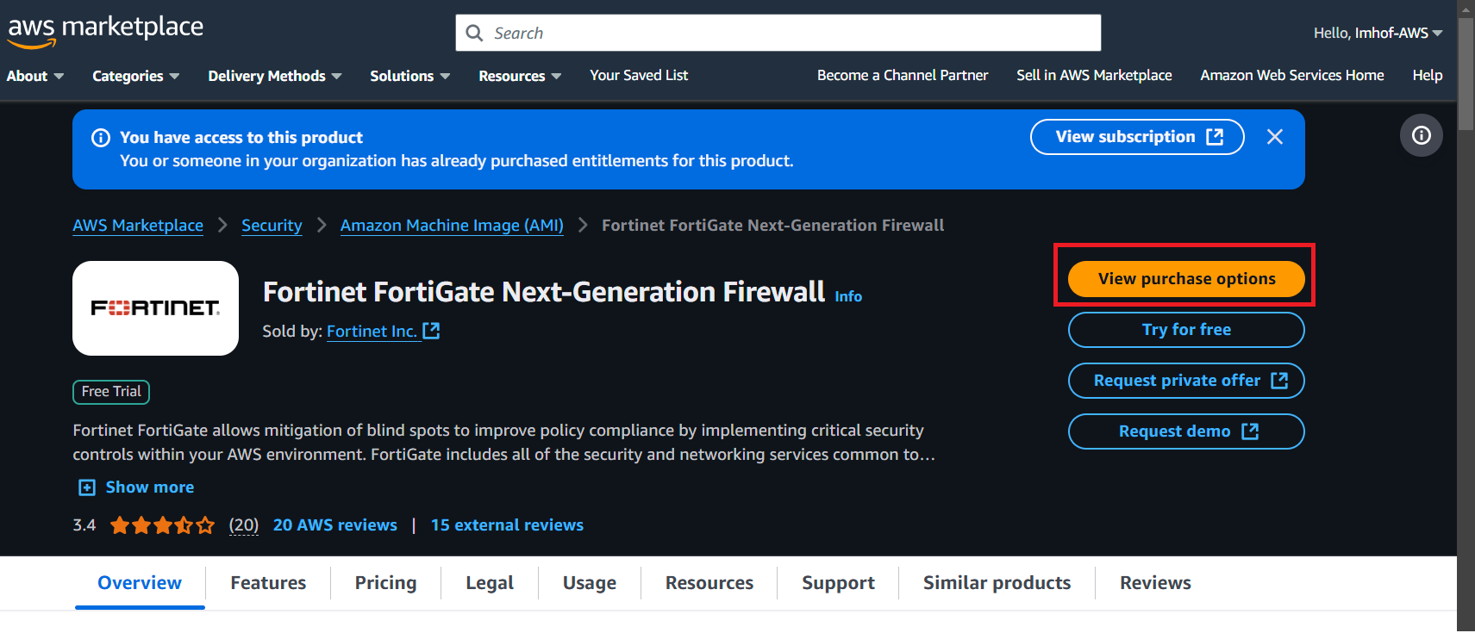

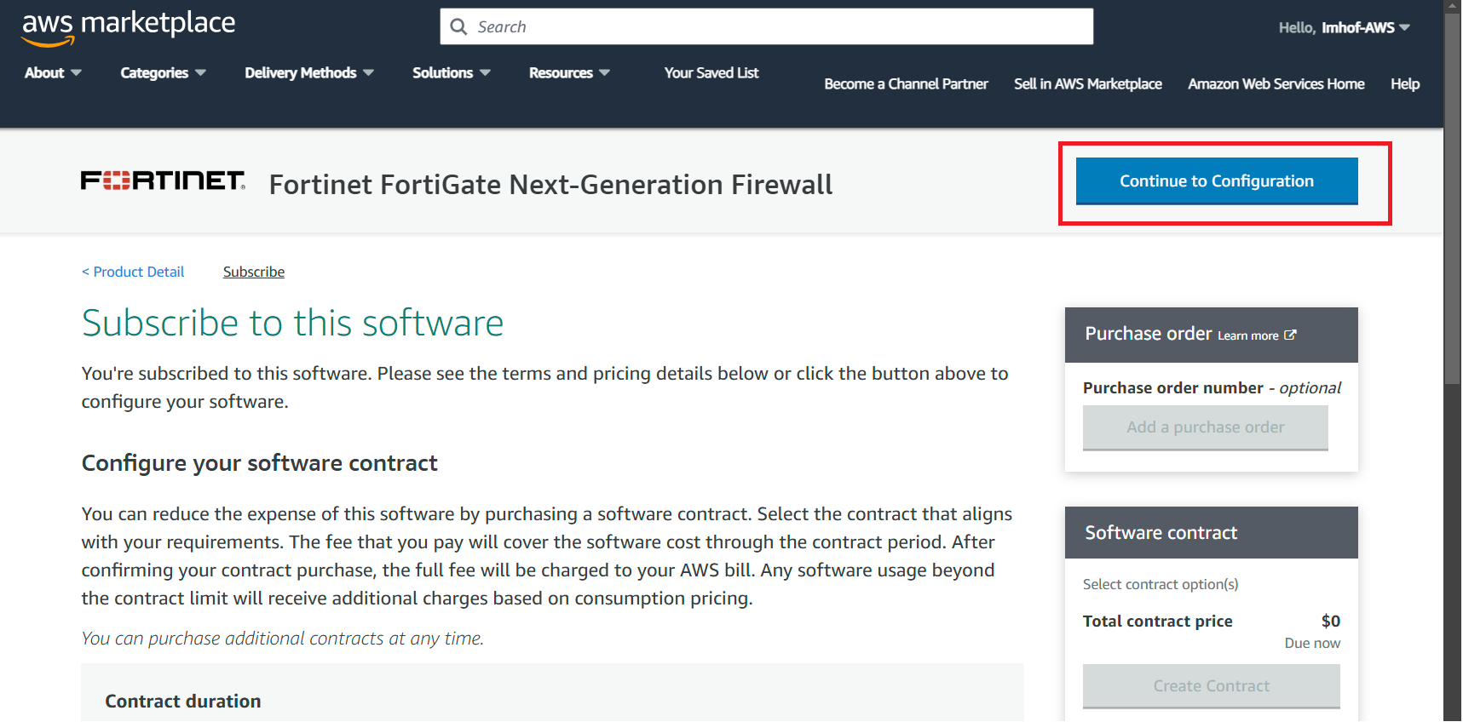

* Fulfillment option: **64-bit (x86) Amazon Machine Image (AMI)**
* Software version: **7.6.2 (Feb 23, 2025)**
* Region: **US East (Ohio)**
* Click on **Continue to Launch**

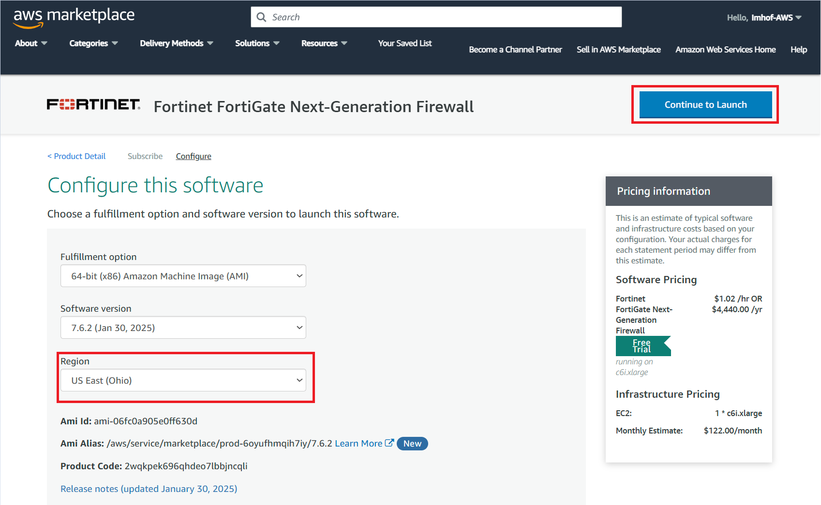

* Choose Action: **Launch from Website**
* EC2 Instance Type: **t2.small**
* VPC Settings: **Select the VPC ID** of your “SingleVMvpc” VPC.
* Subnet Settings: **Select the Subnet ID** of your “singleVMpublic” subnet.
* Security Group Settings: Select **Create New Based on Seller Settings** with the name as **FGT-SG** with the description as **Default FortiGate Security Group**.
* Key Pair Settings:
  + Click on **Create a key pair in EC2**
  + Click on **Create key pair**
  + Name: **KeyPair - FGT**
  + Key pair type: **RSA**
  + Private key file format: **.ppk**
  + Click **Create key pair** and **save your private key**
  + Navigate back to the FGT marketplace page, click on the refresh icon for Key Pair Settings, and select your newly created **KeyPair-FGT**.
  + Click on **Launch**

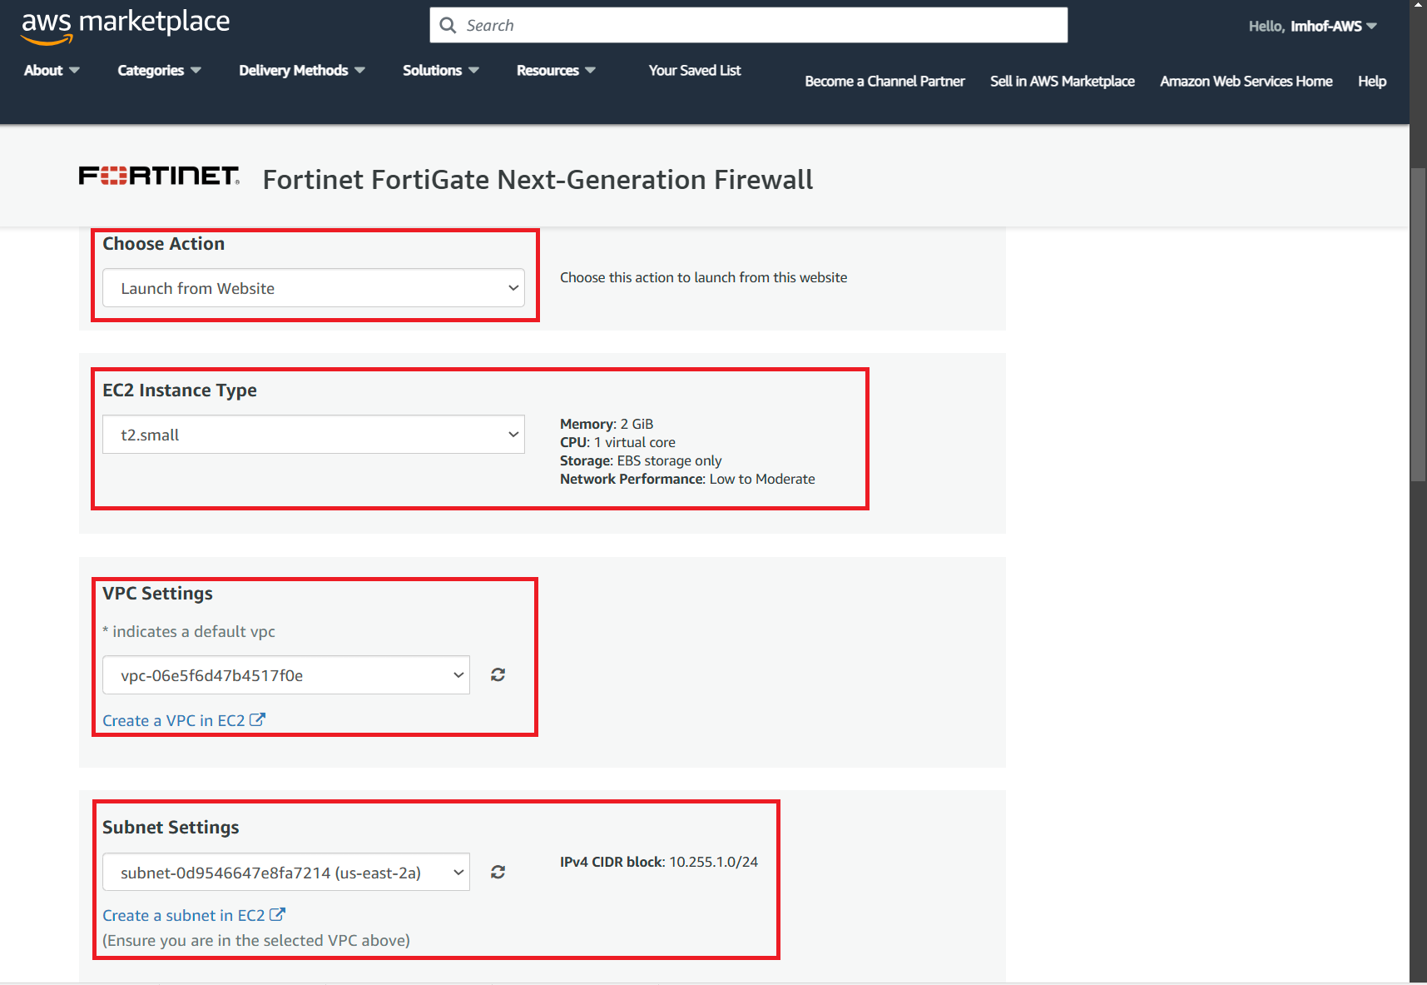

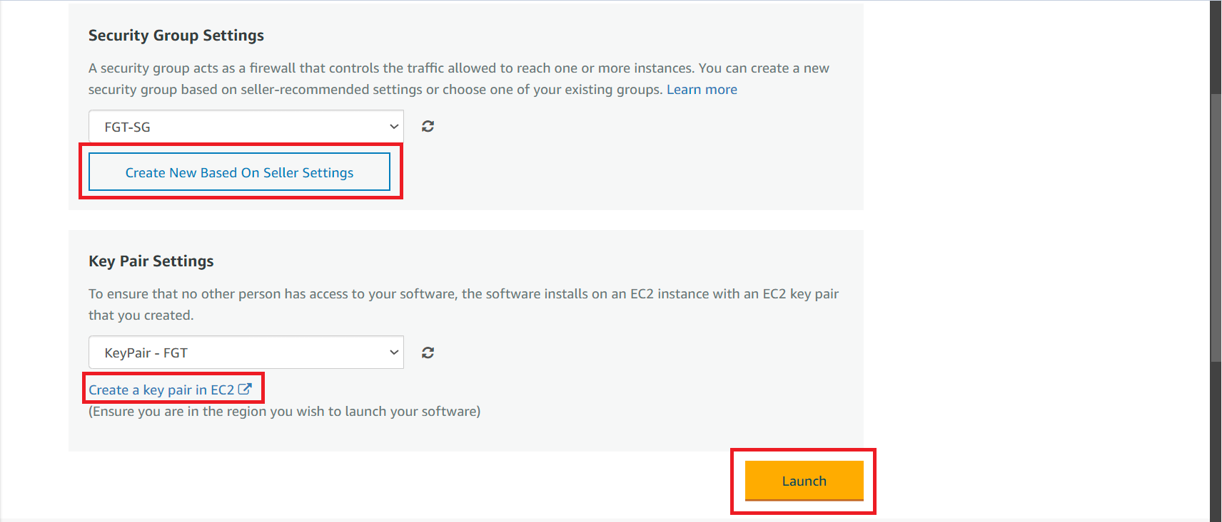

* Choose Action: **Launch through EC2**
* Click on **Launch**

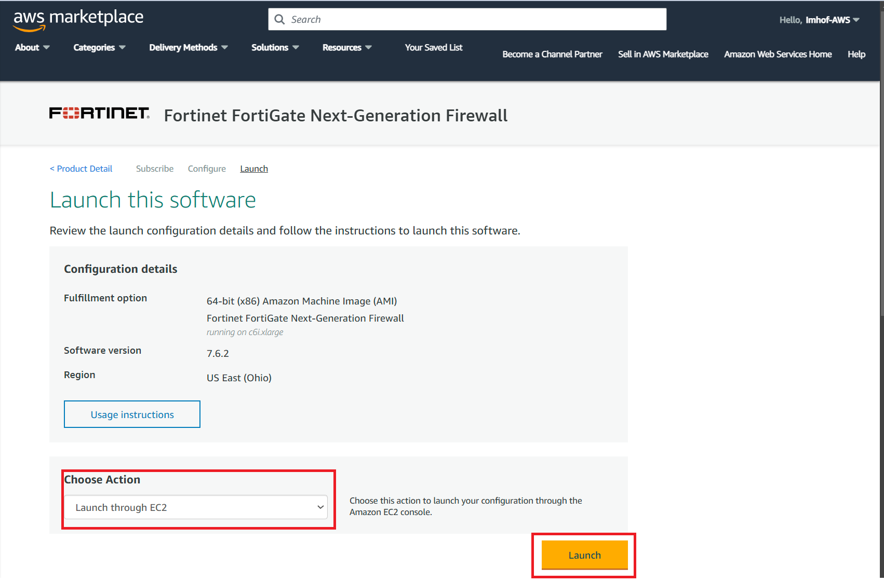

Once the FortiGate virtual machine has fully launched you can view it within the EC2 console. Click on the edit icon and give it the name **SingleFGT**:

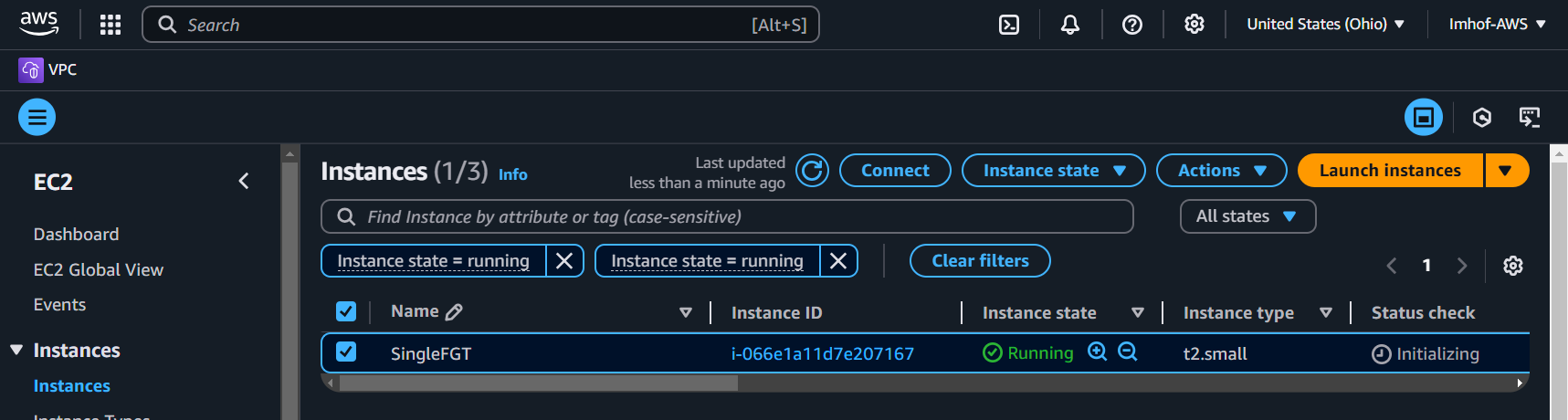

10 – Navigate to Network Interfaces under the EC2 console and create new private ENI by clicking on the button **Create network interface**:

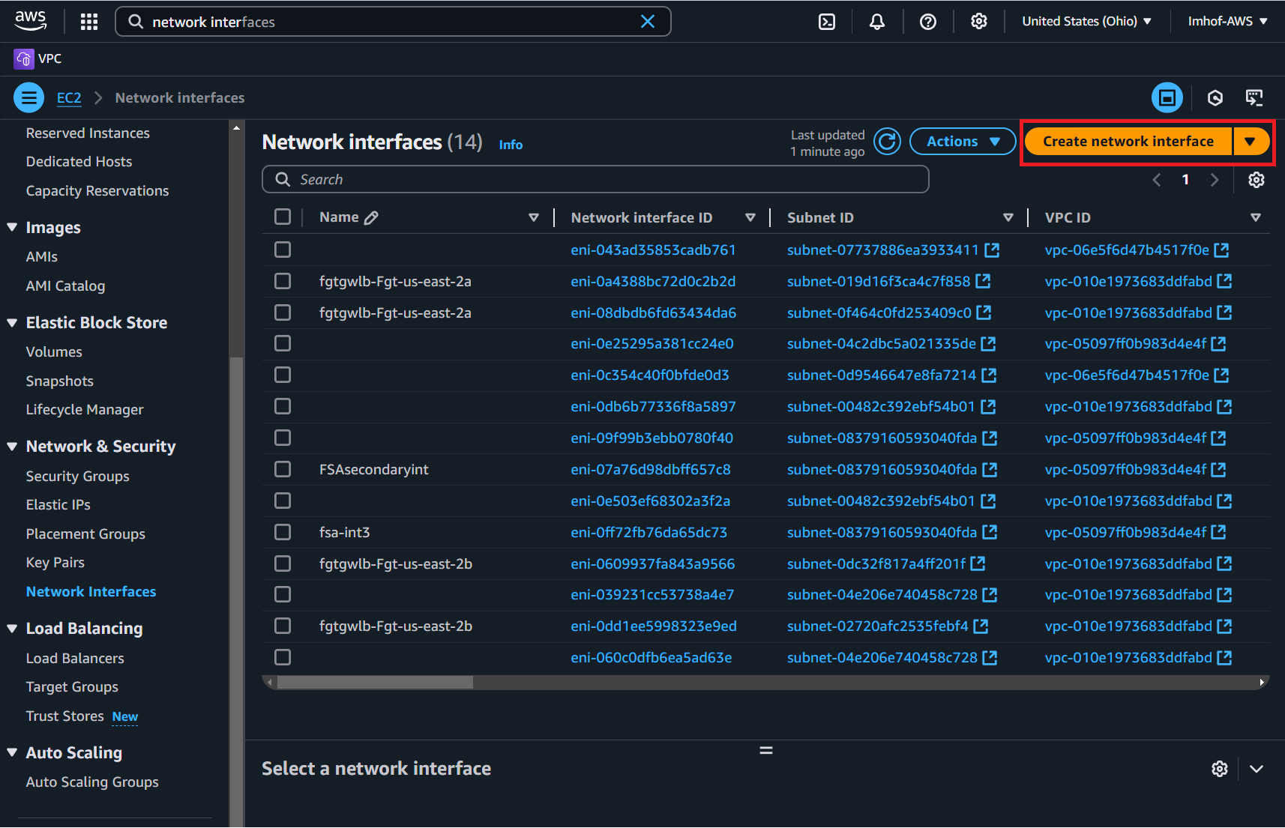

* Description: **SingleVMprivateENI**
* Subnet: **singleVMprivate**
* Security groups: **FGT-SG**

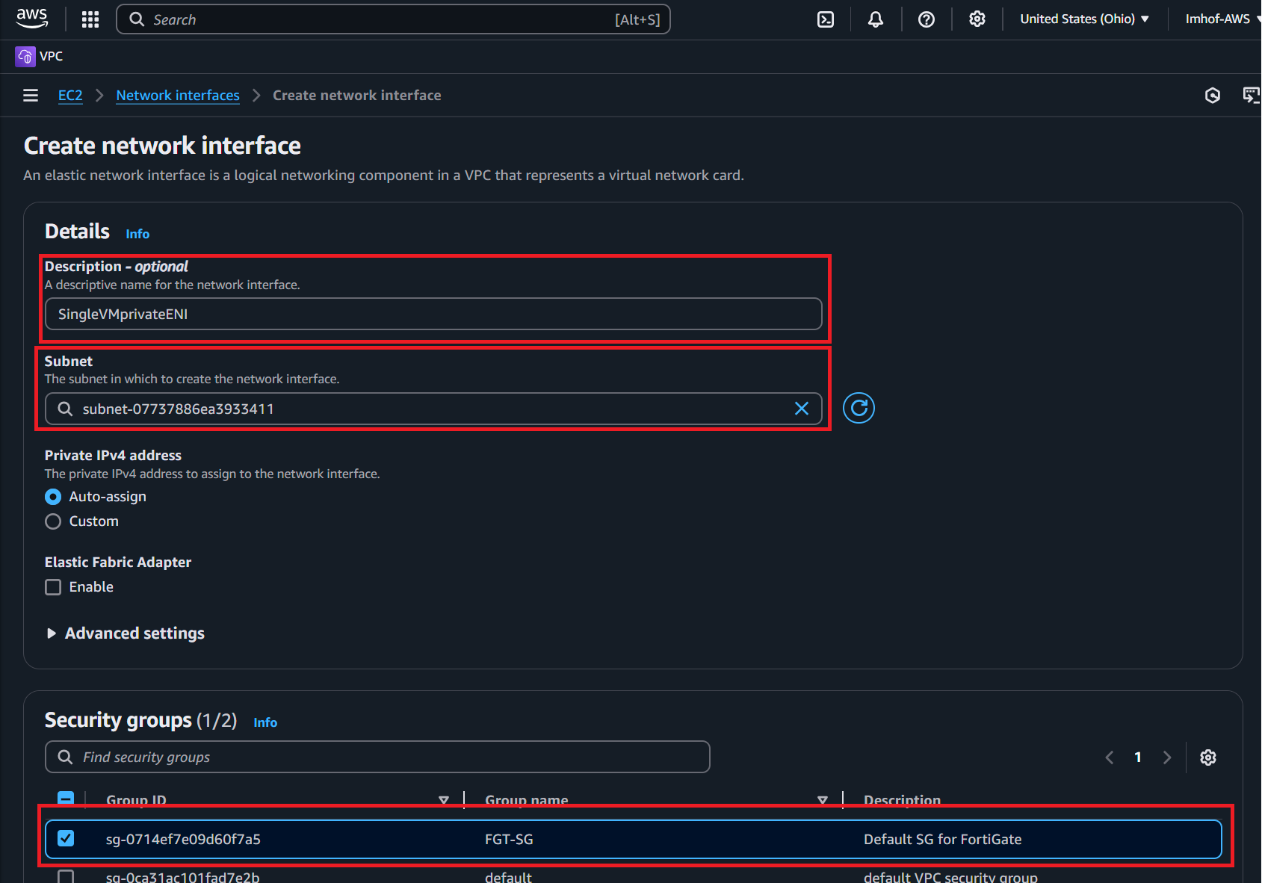

11 – Add new **private ENI** to FortiGate by navigating to the “Instances” section and clicking on the Instance ID for “SingleFGT”:

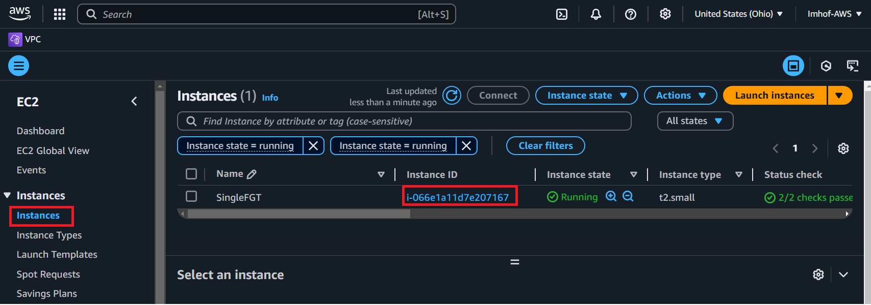

* Click on **Actions -> Networking -> Attach network interface**
* VPC: **SingleVMvpc**
* Network interface: **SingleVMprivateENI**
* Click on **Attach**

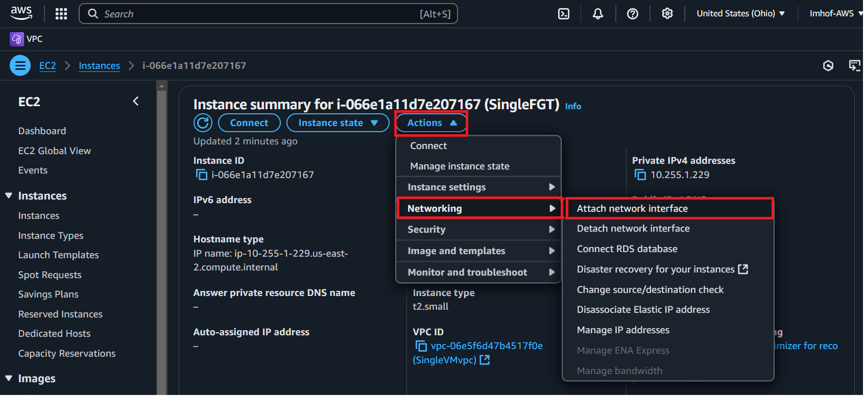

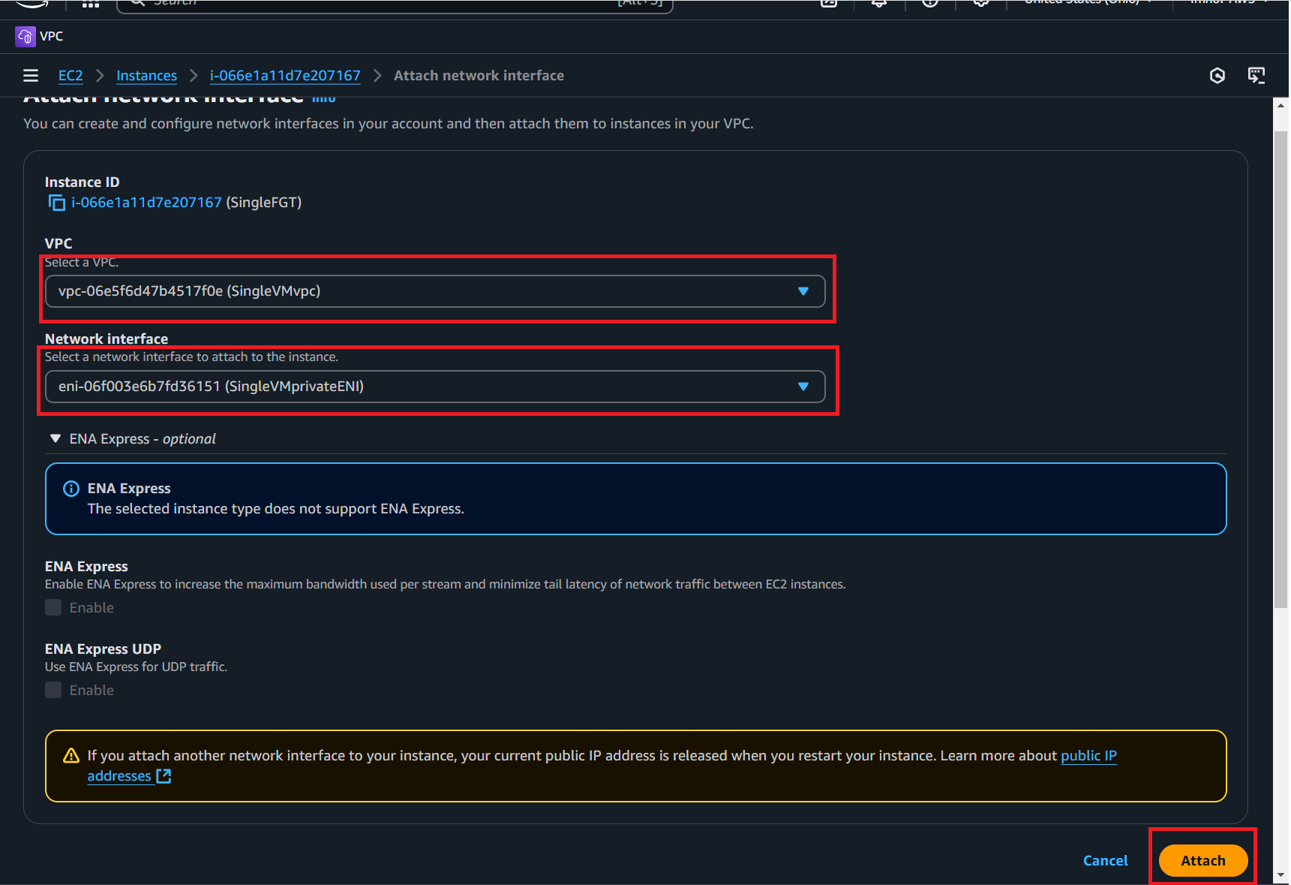

Verify that the new private ENI has been successfully attached by navigating to the FGT EC2 instance then clicking on **Networking**:

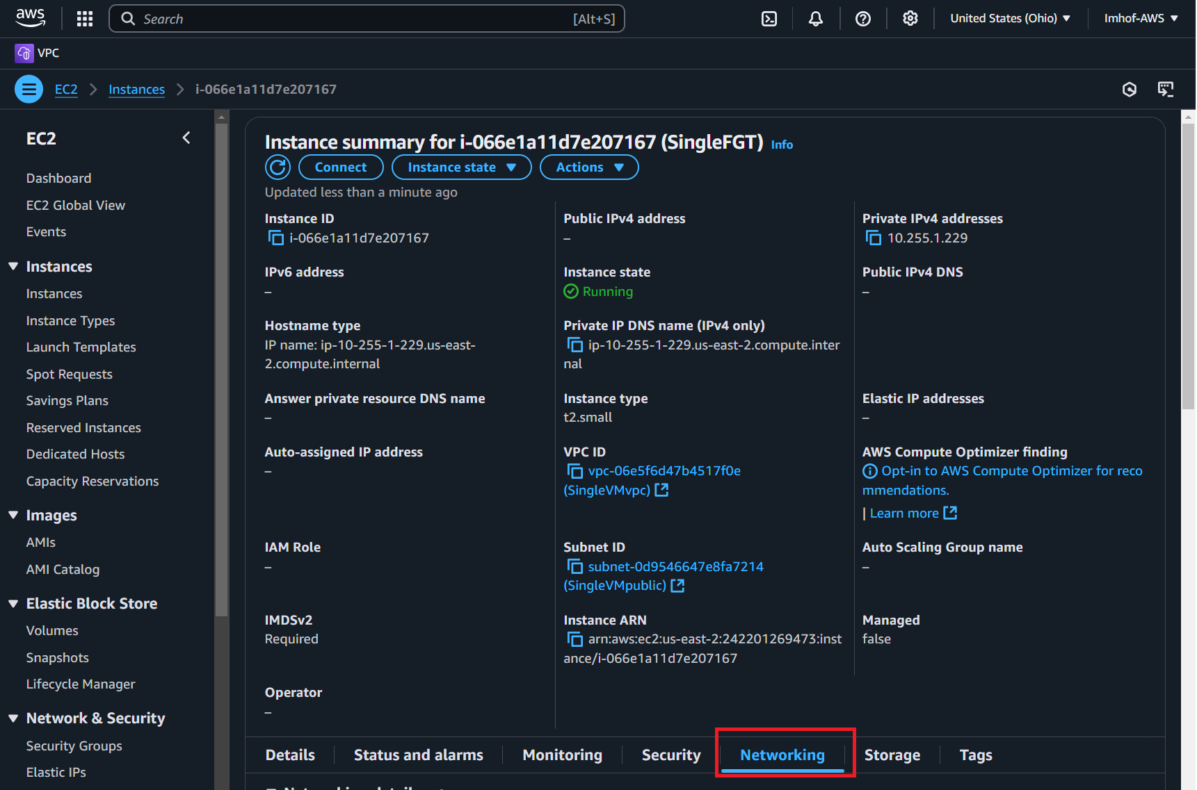

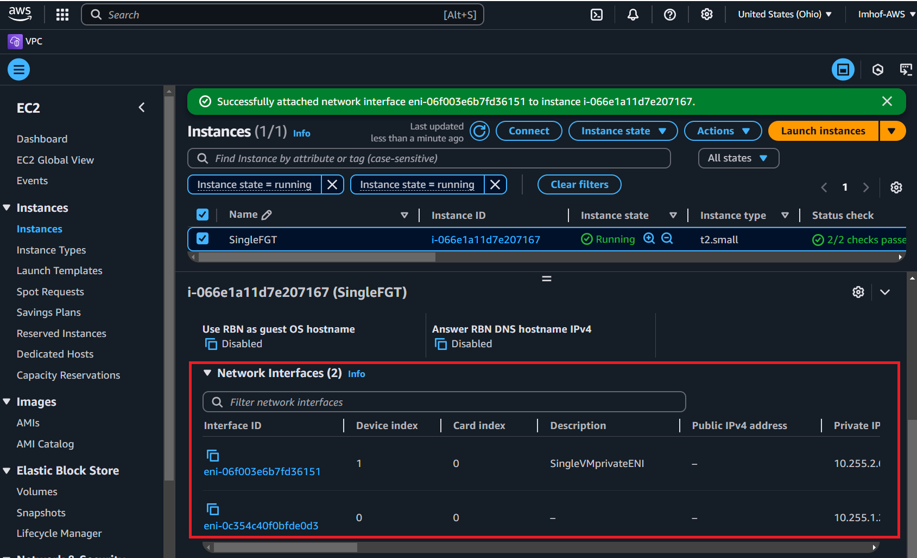

12 – Create new Elastic IP (public IP) to attach to the FGT public interface. This is necessary for connectivity to the internet.

* Navigate to Elastic IPs and click on **Allocate Elastic IP address**

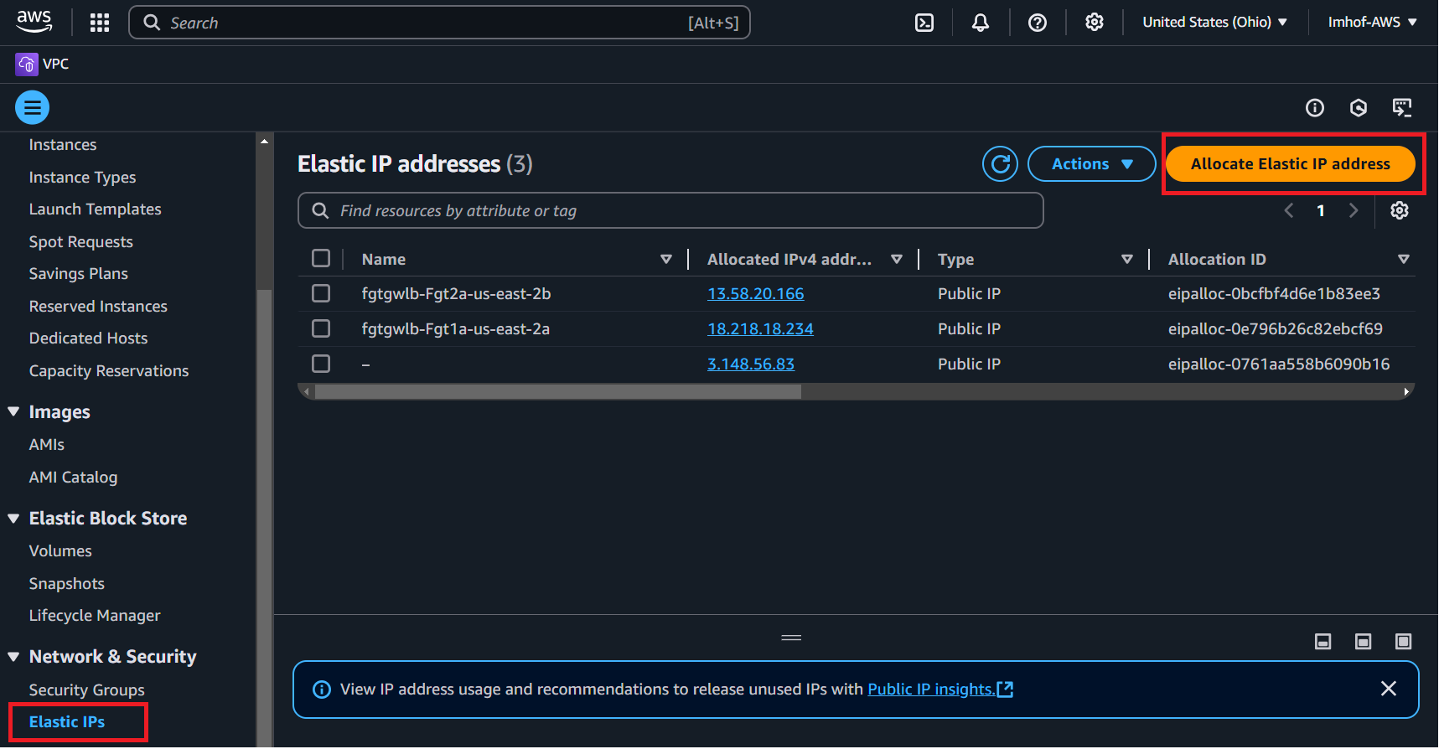

* Select **Amazon’s pool of IPv4 addresses**
* Click on **Allocate**
* Name the address as **SingleVMpublic**

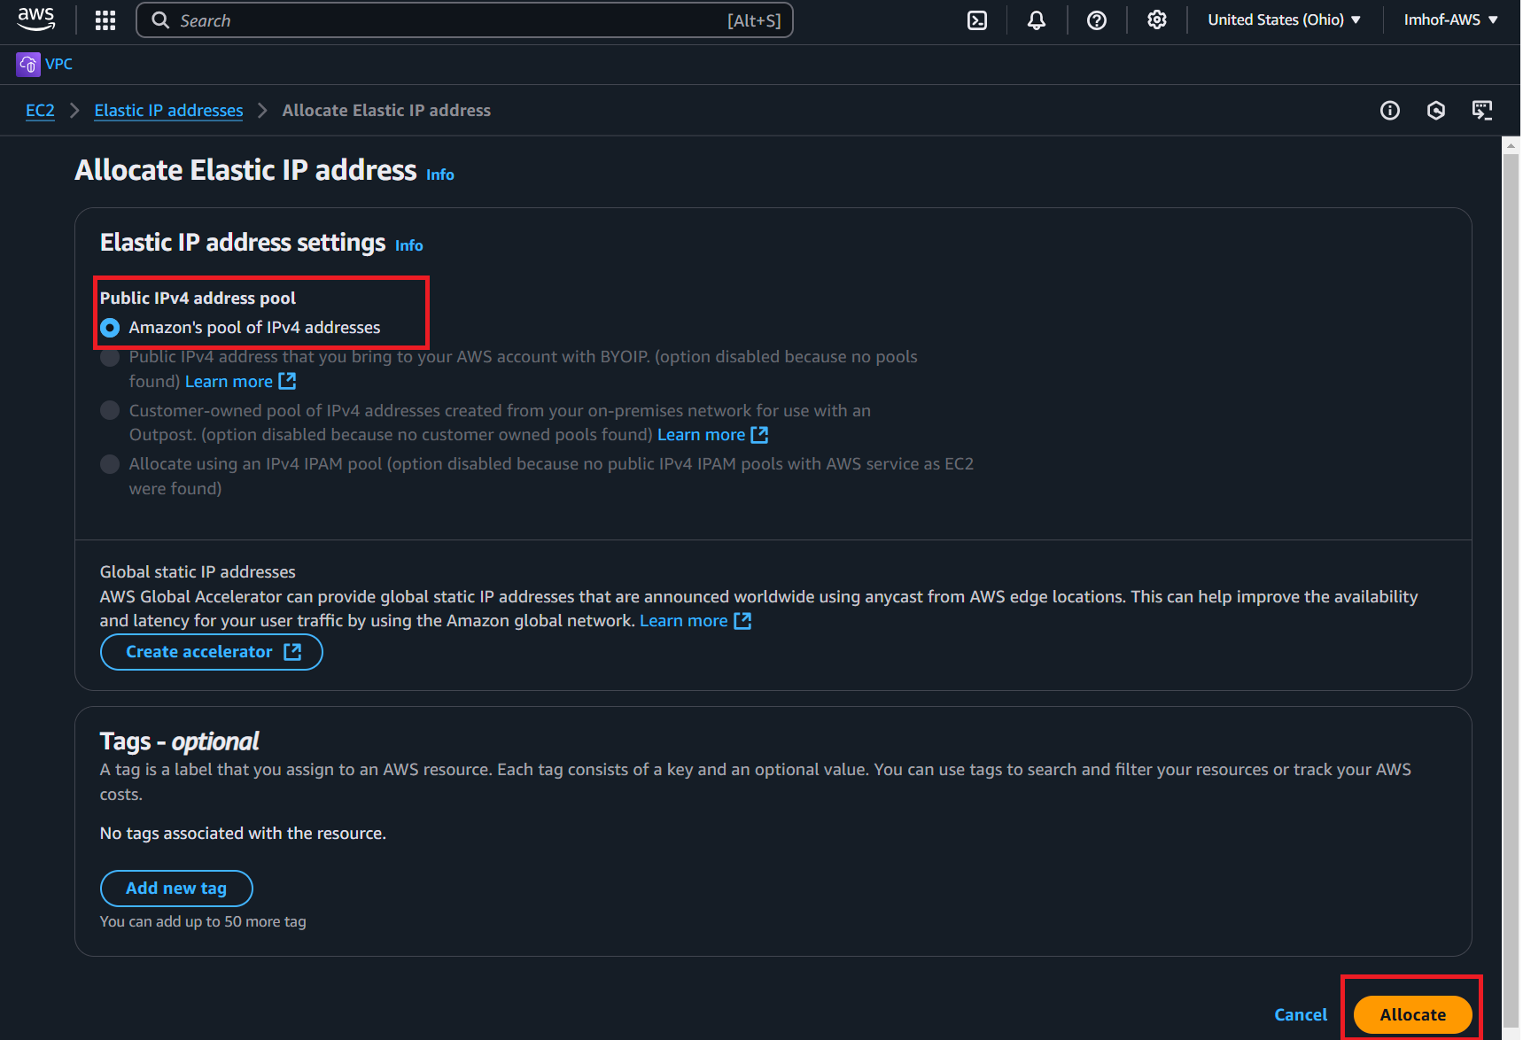

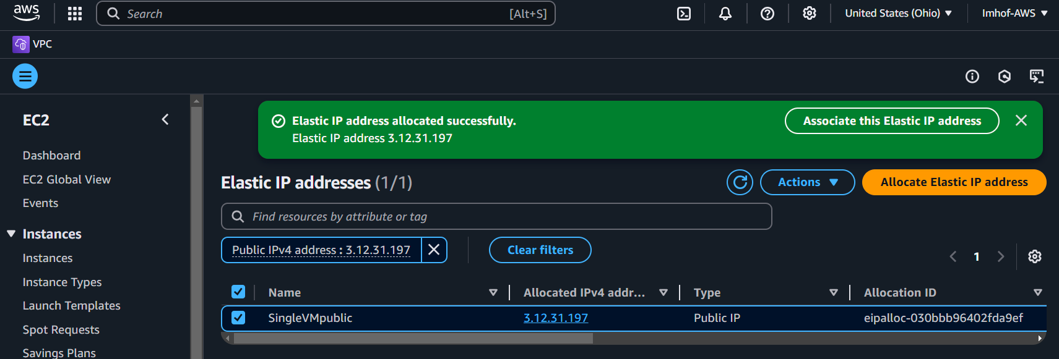

13 – Assign new Elastic IP to the FGT public ENI network interface by navigating to the FGT instance:



* **Actions -> Networking -> Change source/destination check**
  + By default, traffic within AWS will be denied on the ENI if the traffic isn’t destined to that resource directly … this must be changed to allow the resource to receive and process transit traffic.

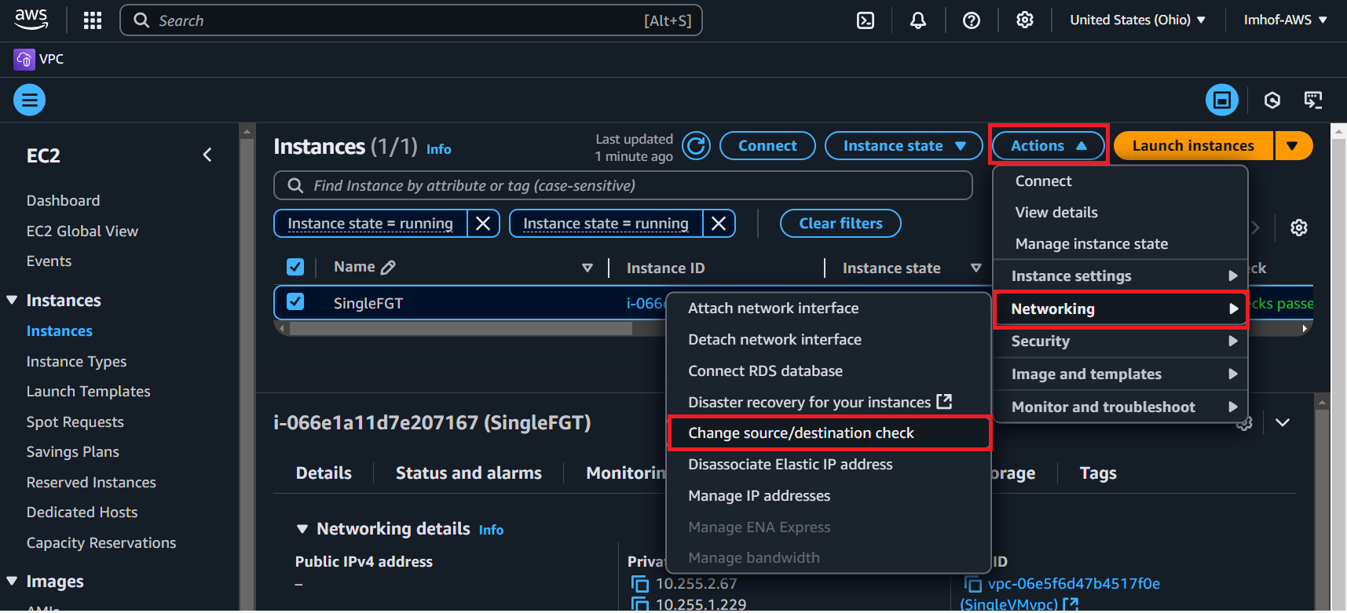

* Select **Stop**
* Click on **Save**
* Verify that the source/destination check has been disabled by navigating to each ENI and clicking on Actions -> Change source/destination check and verifying that it is disabled.

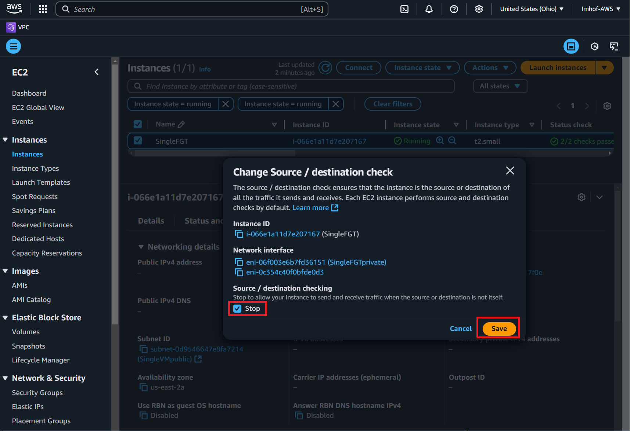

Navigate to the **SingleVMpublicENI** to associate the elastic IP to it:

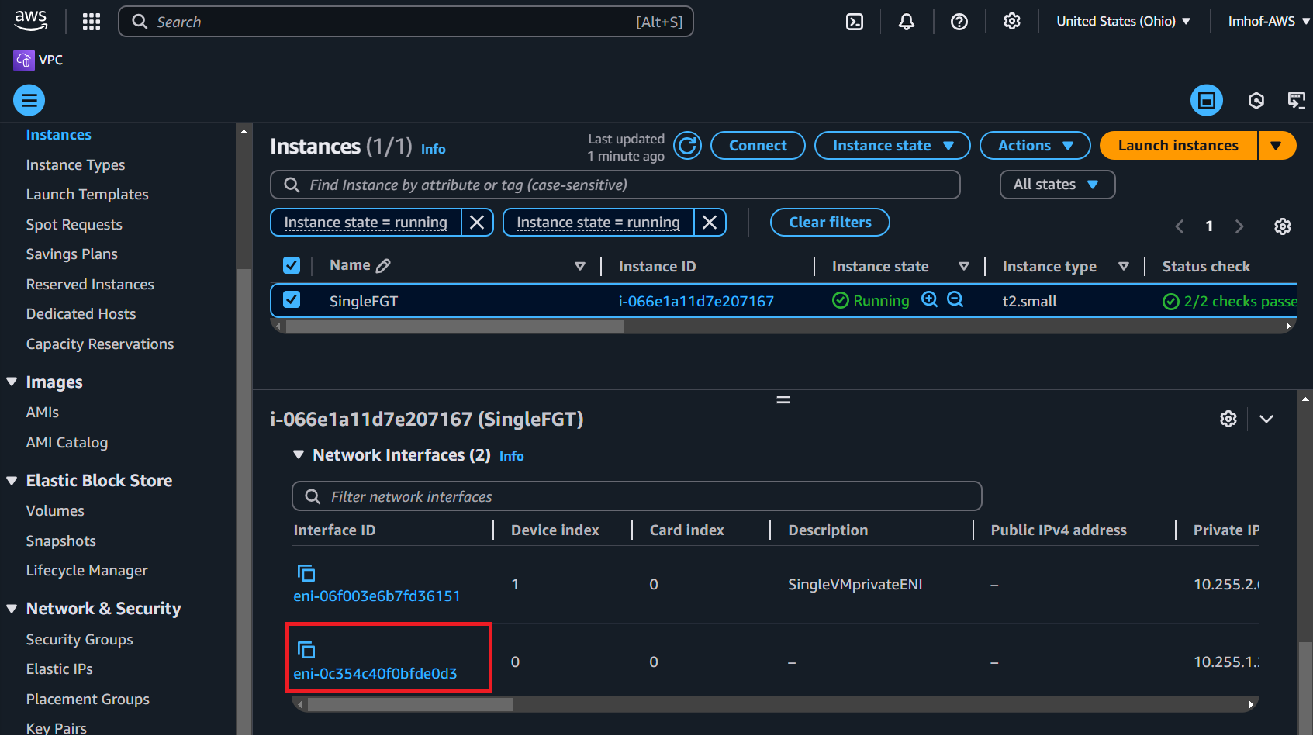

* **Actions -> Associate address**
* Elastic IP address: **SingleVMpublic**
* Private IP address: **Private IP assigned to the public ENI**
* Click on **Associate**

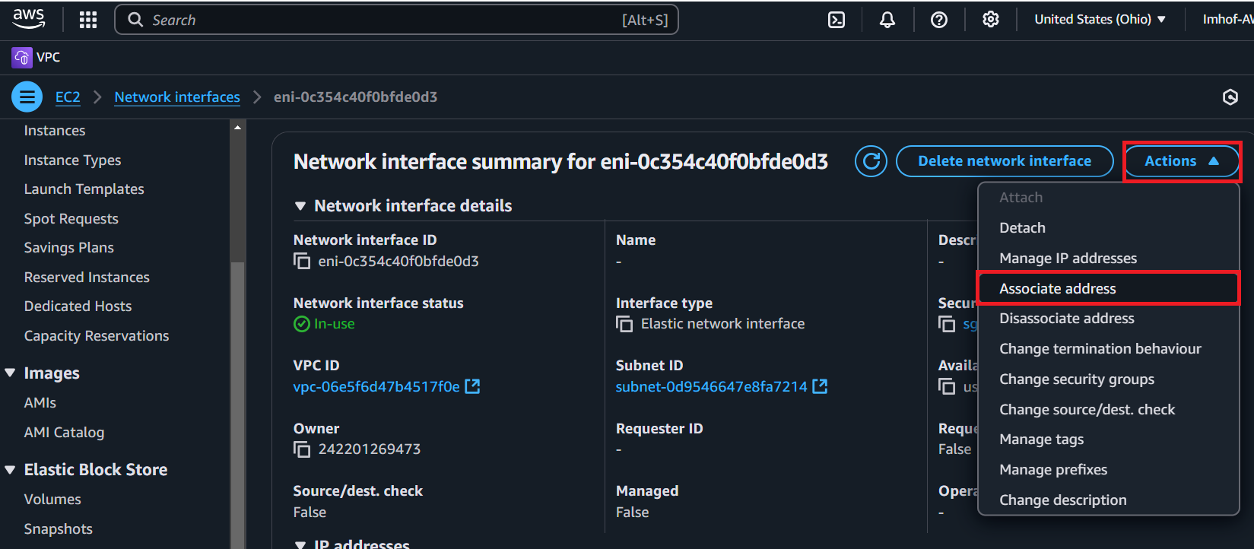

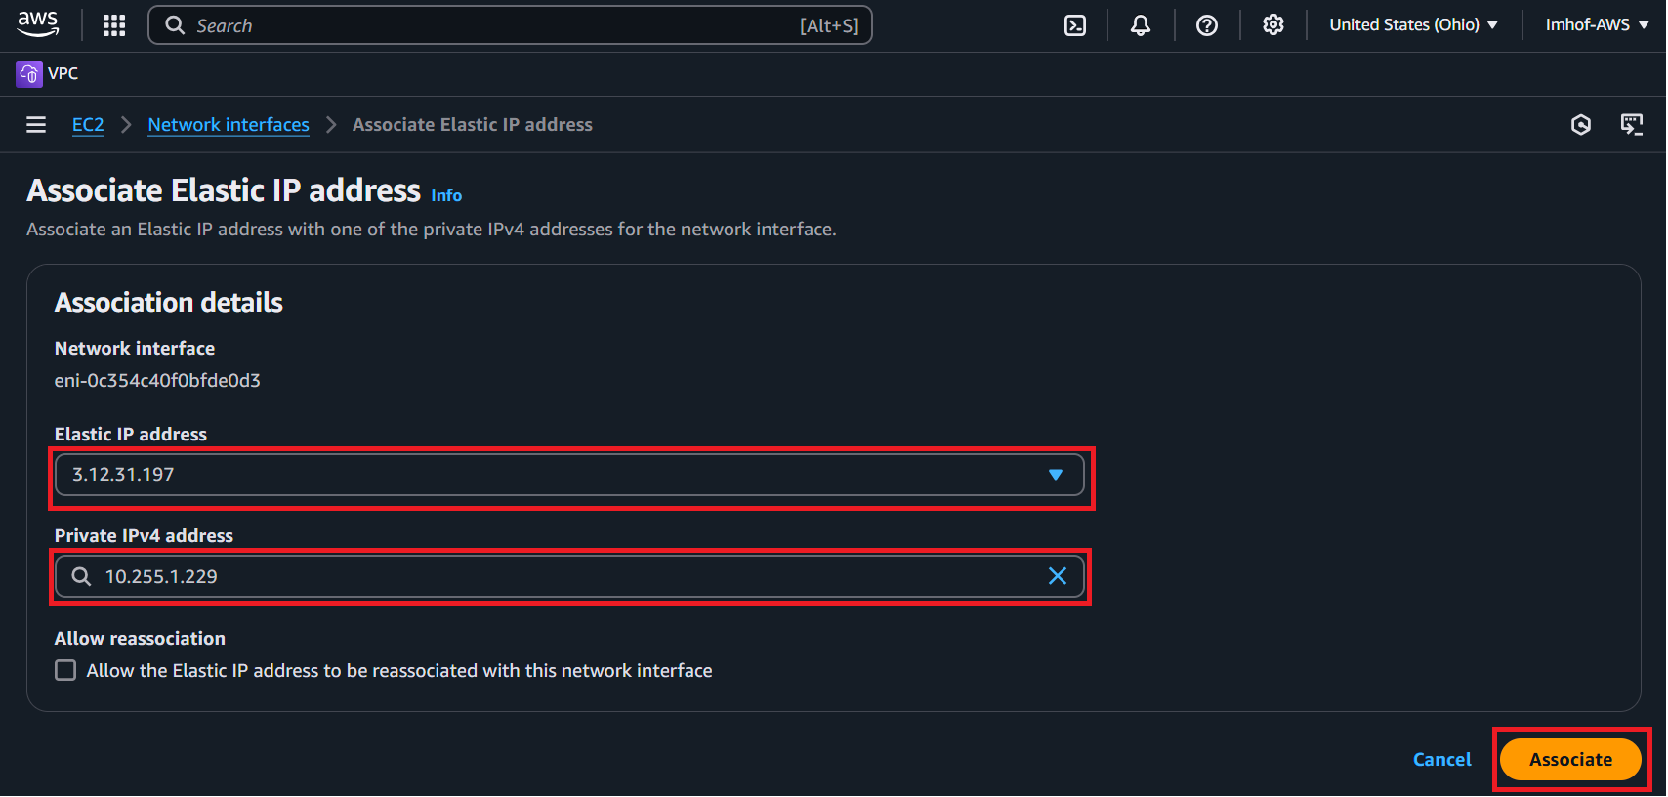

14 – Create route table to force outbound internal traffic through FGT by navigating to the VPC console and clicking on “Route tables”:

*** First note the IP of the internal FGT interface ***

* Click on **Create route table**
* Name: **SingleVMinternalRT**
* VPC: **SingleVMvpc**
* Click on **Create route table**

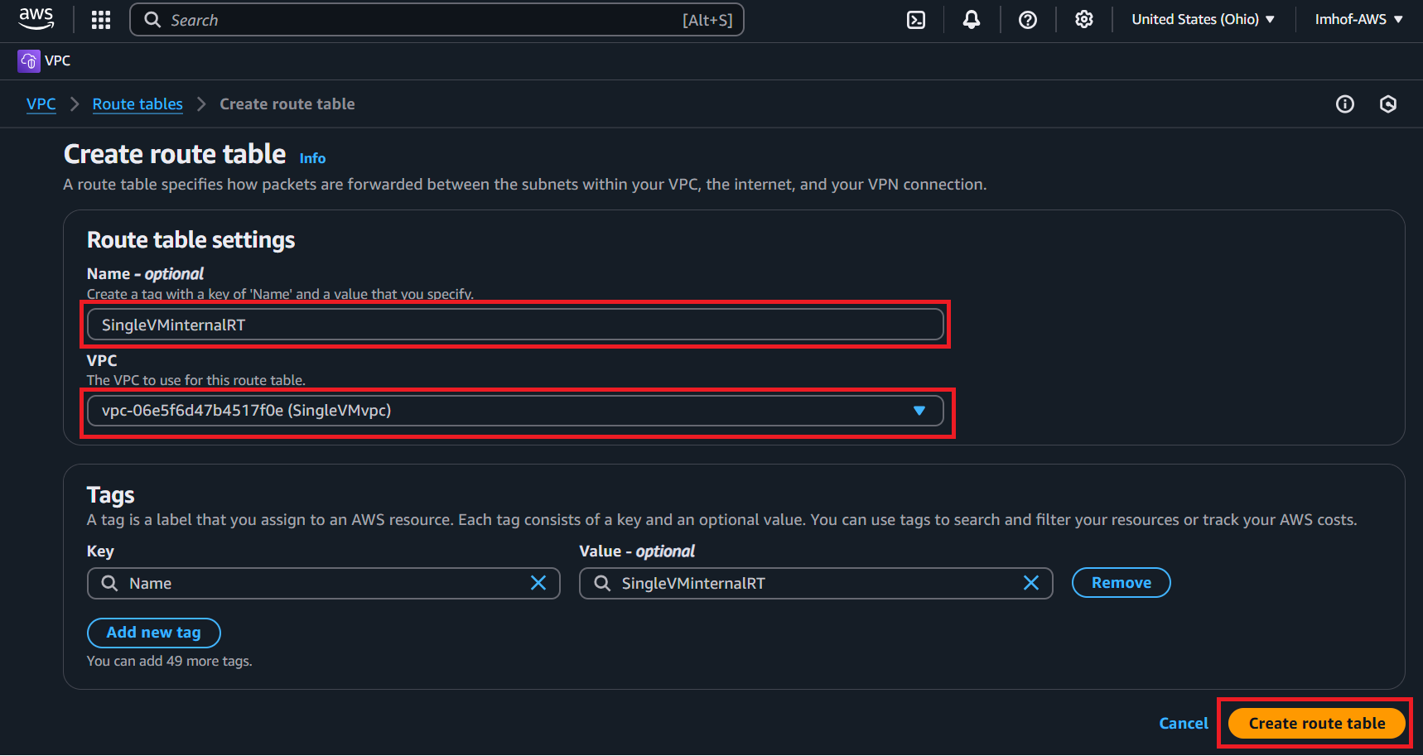

* Associate the new route table to the private/internal subnet:
  + **Subnet associations -> Edit subnet association**
  + Select **singleVMprivate**
  + Select **Save associations**

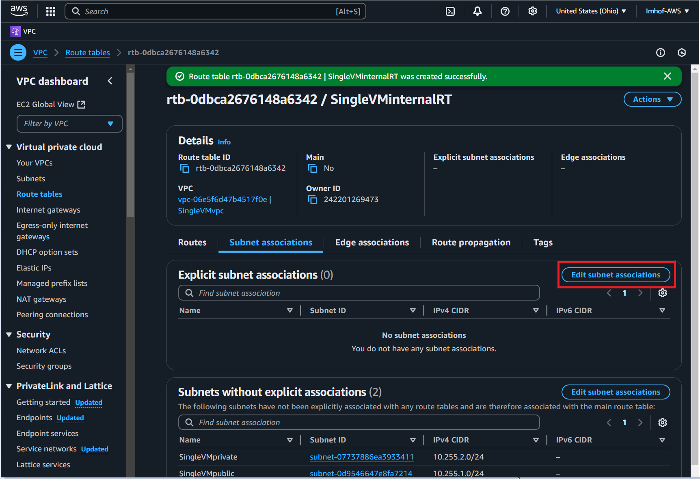

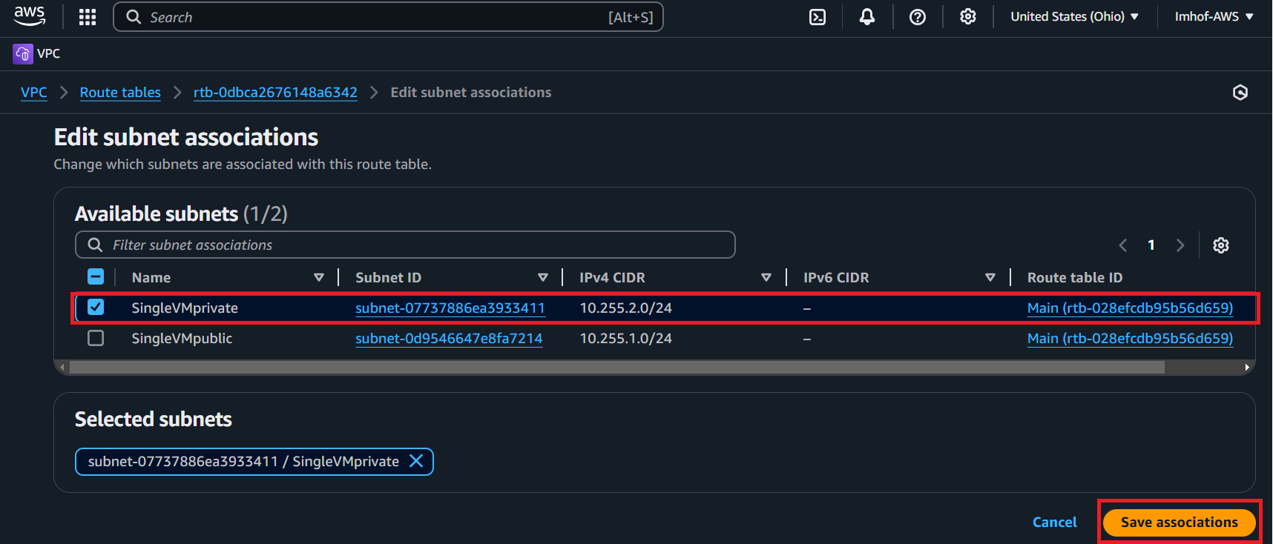

Edit the routes within the route table to force all internet outbound traffic through the FGT private ENI to enable traffic processing by FortiGate:

* **Routes -> Edit routes**
* Click on **Add route**
* Destination: **0.0.0.0/0**
* Target: **Network Interface** then select the **private ENI**

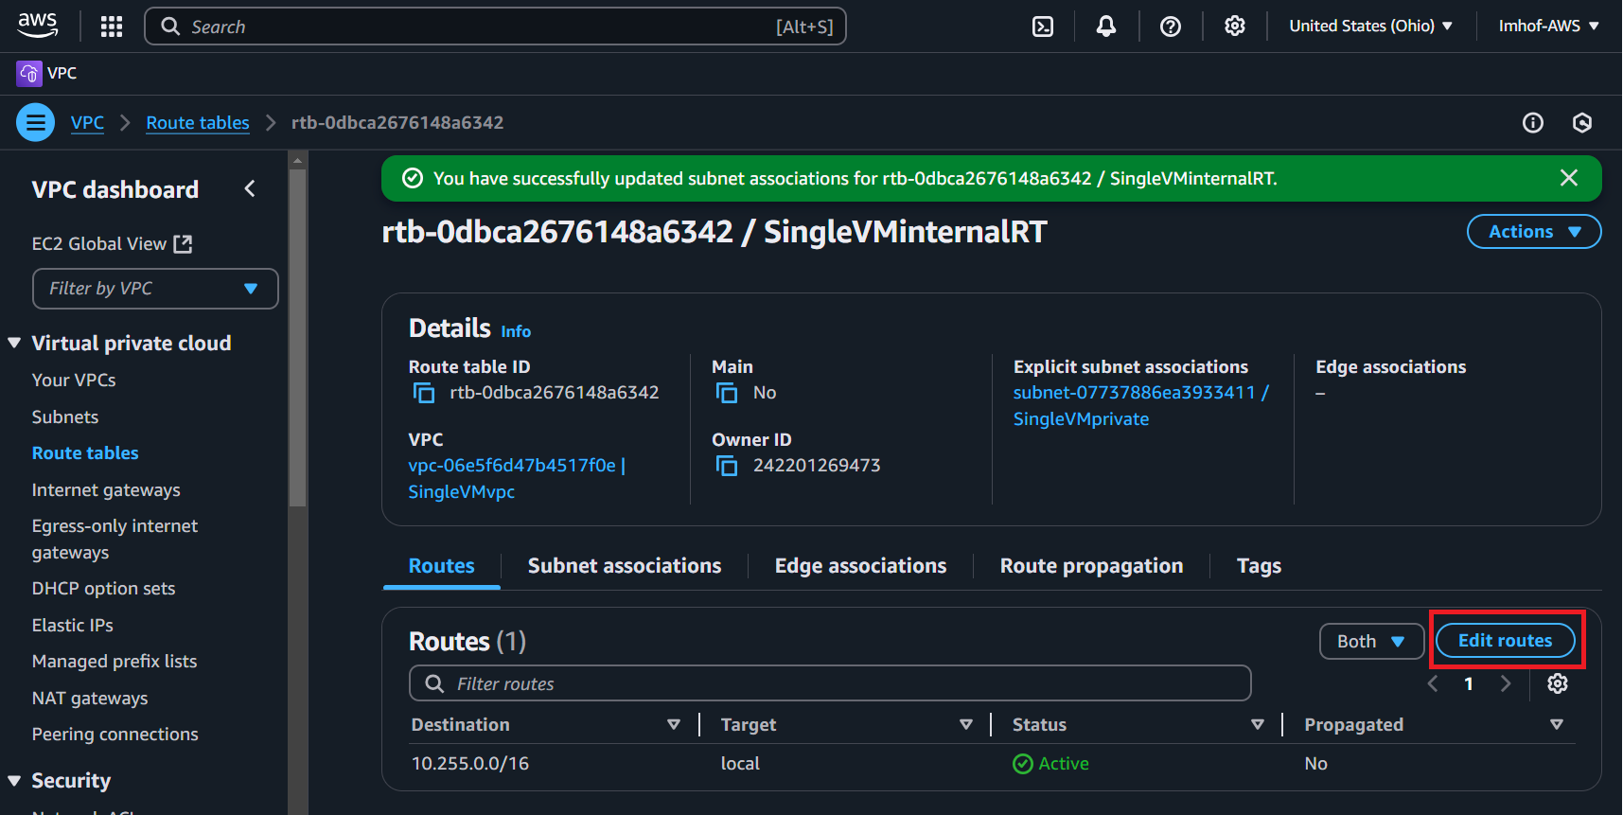

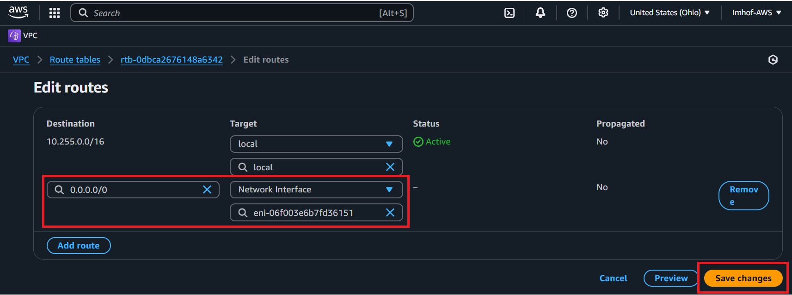

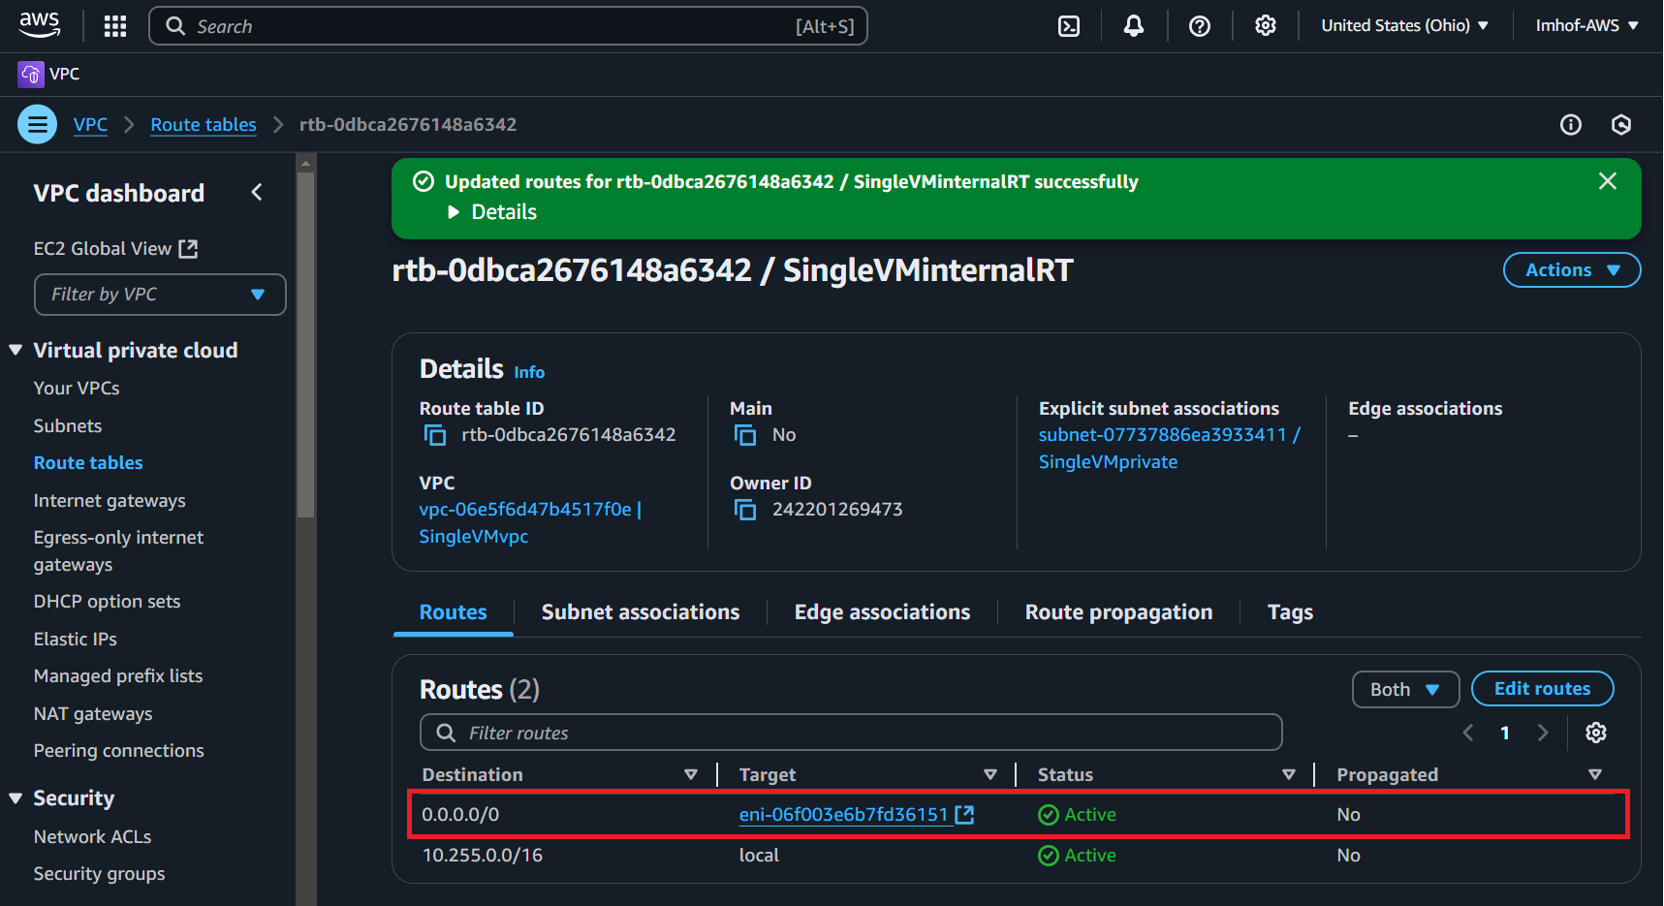

15 – Follow steps from 14 and create route table to force outbound internet traffic through IGW

* Navigate to the “Route tables” page through the VPC console
* Rename the public route table to **SingleVMExternalRT**
* Click on its Route table ID
* **Subnet associations -> Edit subnet associations**
* Select **singleVMpublic**
* Click on **Save Associations**

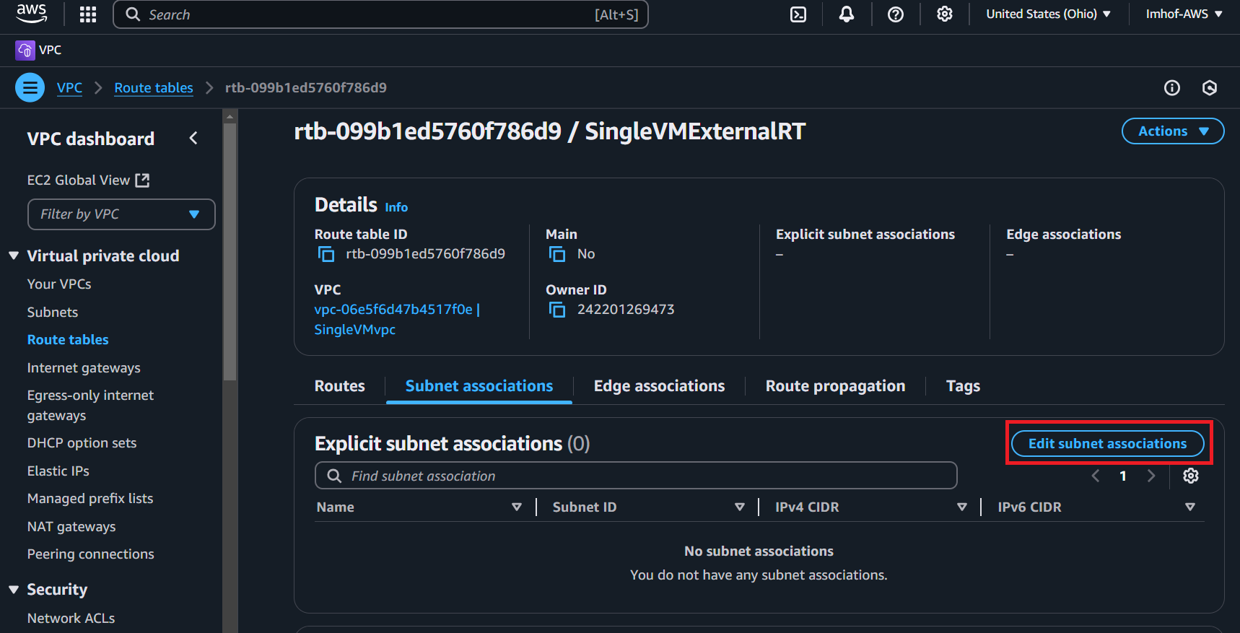

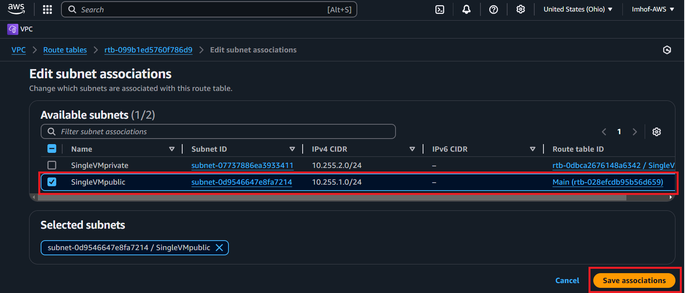

Edit the routes of the SingleVMExternalRT to force outbound traffic through the IGW:

* **Routes -> Edit routes**
* Click on **Add route**
* Destination: **0.0.0.0/0**
* Target: **Internet Gateway** then **IGW-singleVM**
* Click **Save changes**

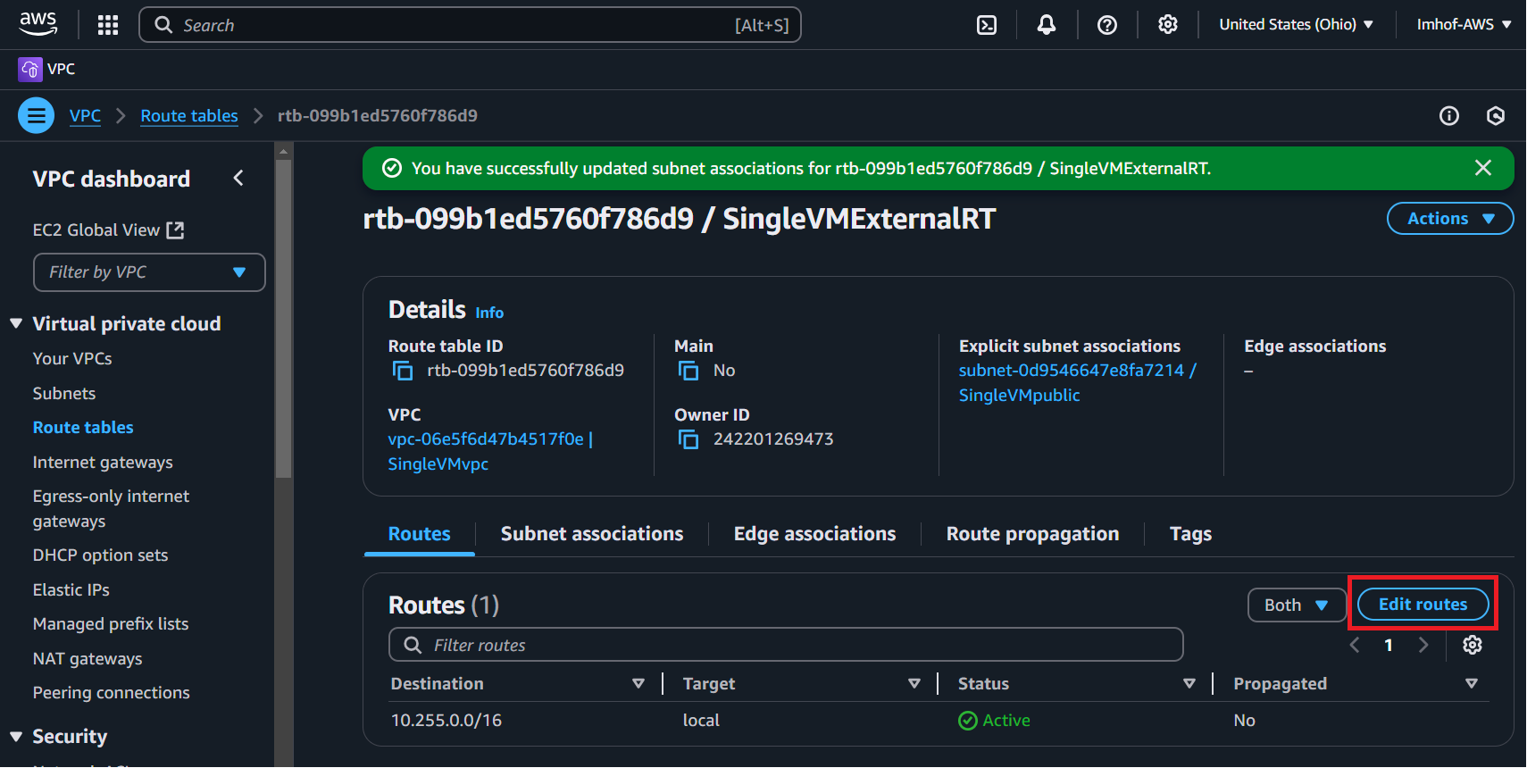

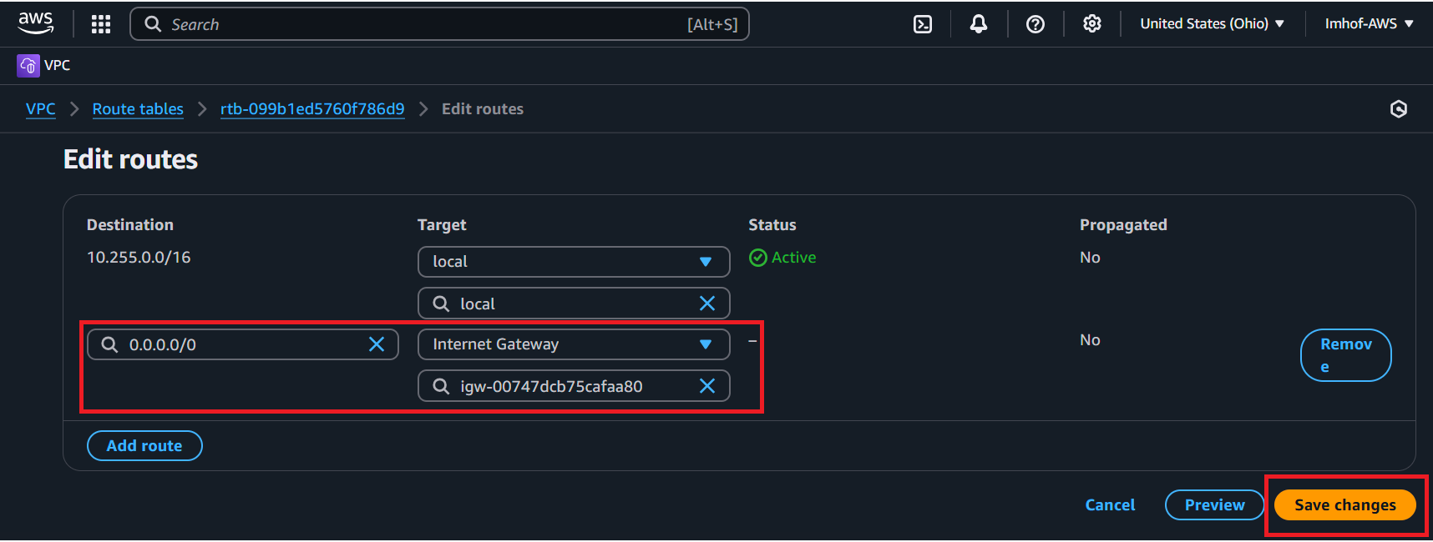

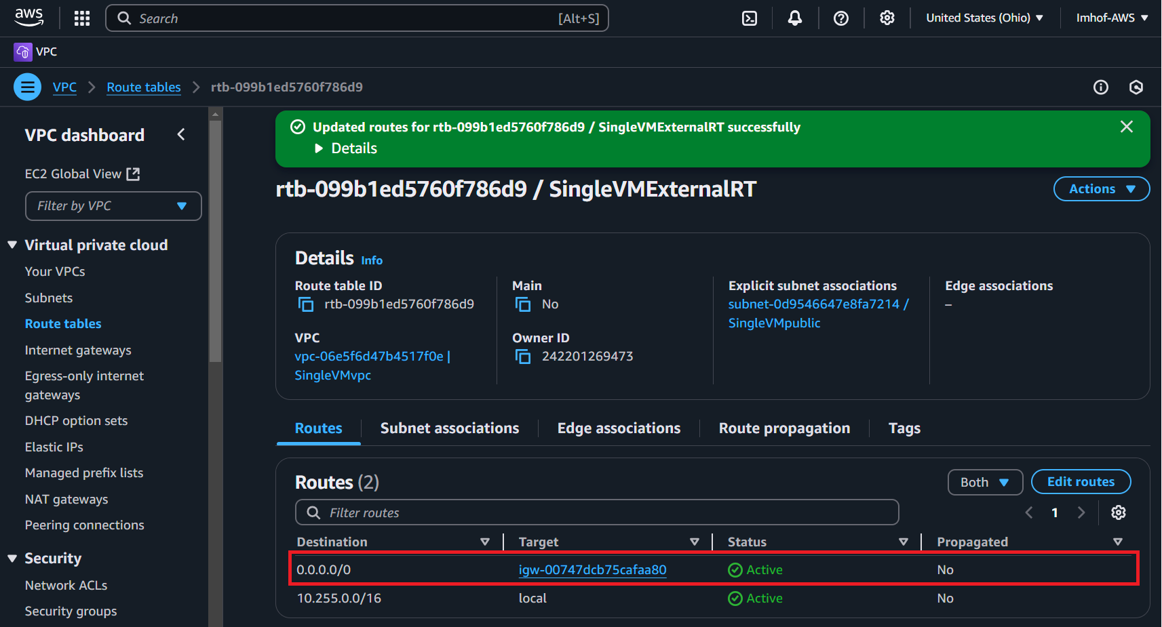

16 – Navigate to the EC2 console and access FGT

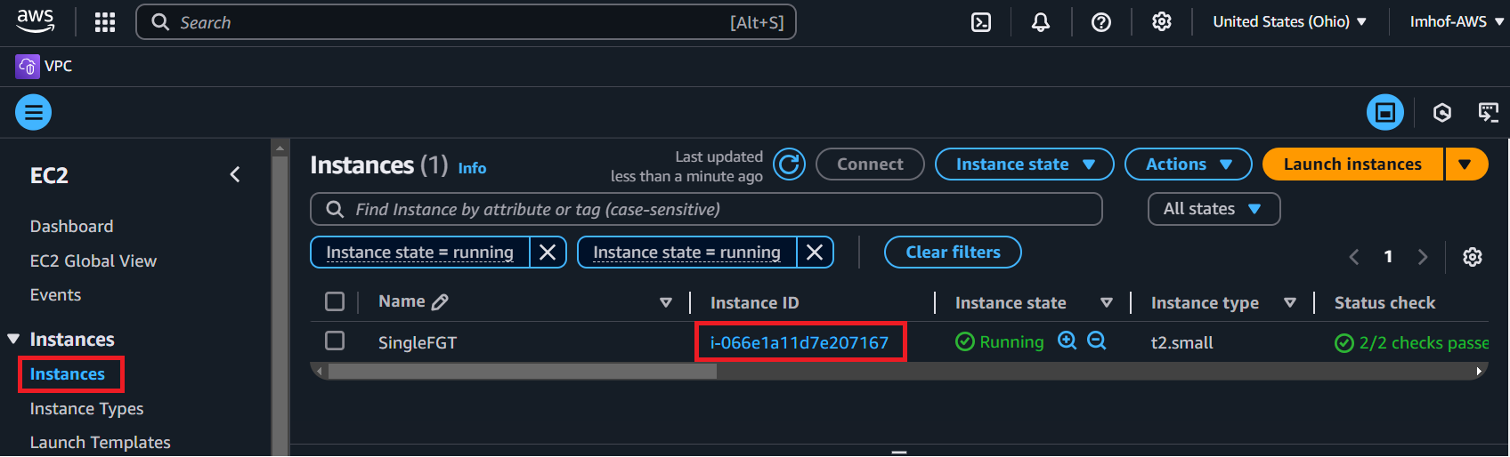

Copy the Instance ID as it will be the password to initially access FGT (**admin/Instance ID**)

